Botanický ústav AV ČR Vás zve na přednášku

Dr. Garrett E. Crow
University of New Hampshire, Department of Plant Biology, Durham, U.S.

“Biodiversity of Aquatic Plant: Temperature versus Neotropics. Is Northeastern North America the Amazonia of Diversity for Aquatic Plants?”

Přednáška se bude konat ve středu 13.10 od 13:30 v zasedací místnosti Botanického ústavu (velký zámek, 2. patro před redakcí Folia Geobotanica)

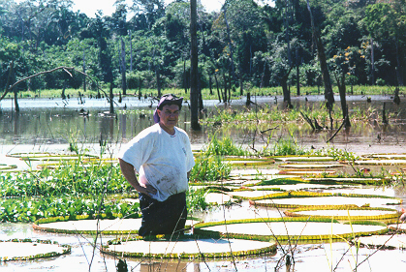

Dr. Garrett E. Crow is a taxonomist and phytogeographer with a special interest in biodiversity in aquatic vascular plants. He is Professor of Botany and Director of the Herbarium, Department of Plant Biology, University of New Hampshire, and currently serves as department Chairman. He has had extensive experience in temperate and tropical aquatic ecosystems. He holds a M. S. and .Ph.D. from Michigan State University. He is co-author of the definitive 2-volume taxonomic work: Aquatic and Wetland Plants of Northeastern North America, University of Wisconsin Press, Madison, WI, USA (2000), and author of Plantas acuáticas del Parque Nacional Palo Verde y Valle Tempisque, Costa Rica / Aquatic plants of Palo Verde National Park and the Tempisque Valley, Costa Rica. (A bilingual field guide). Instituto Nacional Biodiversidad (INBio), Santo Domingo de Heredia, Costa Rica (2002). He is to be the lecturer of course “Aquatic plants: environmental adaptations, biodiversity and phytogeographic distribution” organized by Charles University, Faculty of Science, Praha as a part of doctoral project Local adaptations in plant populations.

