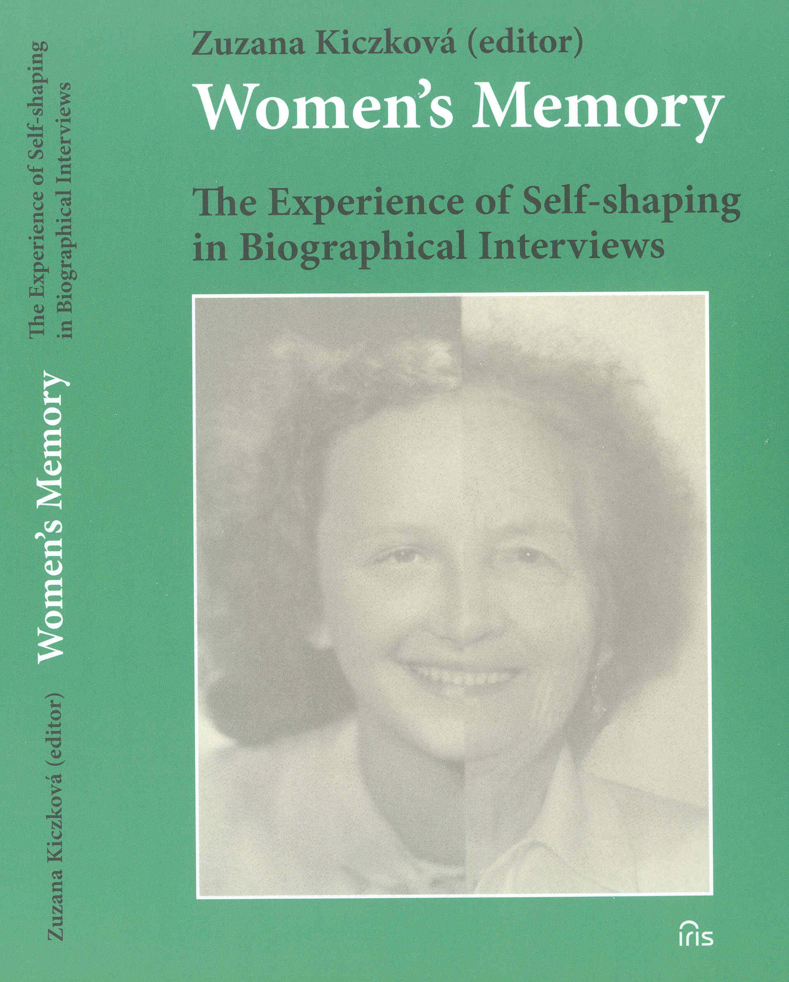
Zuzana Kiczková (editor)

Women’s Memory
The Experience of Self-shaping in Biographical Interviews

Published by
IRIS
BRATISLAVA 2006

Authors:

Zuzana Kiczková: Parts 1, 2 and 3
Zuzana Kiczková, Barbora Kachničová,
Antónia Furjelová, Jana Tesáková: Parts 4, 5, 6 and 8
Marta Botíková: Part 7

Translation: Mgr. Ivan Lacko, PhD.
Language editor: Mgr. Zuzana Kováčová,B.A.

Reviewers: PhDr. Dagmar Smreková, CSc.
Doc. PhDr. Etela Farkašová, CSc.

Cover design: Matúš Kiczko

ISBN 80-89238-07-6
219 p.

The book has been published with the financial support of the OPEN SOCIETY FOUNDATION,
Bratislava

Price: 299 Sk

Order:
by phone: 00421 2 4564 4121, fax 00421 2 4564 4102
by post: IRIS, P.O.Box 16, 82013 Bratislava 213
by e-mail: iris-knihy@iris-knihy.sk
internet: www.iris-knihy.sk

INTRODUCTION

It took a long time to put this book together. At first, it seemed that it would be fairly easy to do the interviews with women according to a set of principles (defined by the members of the international project Women's Memory), and then transcribe and publish them. Slowly, but surely, however, we saw a new, colorful world open up before us – the world of the women’s stories which captured our attention and sensitized us to the details of everyday survival of the interviewed women. The initial deep empathy we felt towards these women was motivated by the conviction that a space needed to be created for them in order to make their voice be heard. Using this voice, they could reconstruct from memory the process of shaping their own identity, i.e. how they were becoming themselves during the period they lived in. The women would also be given an opportunity to express their opinion about what they thought they meant to others. We carefully listened to their stories and progressively found out – to our great surprise – that this was also our space, because all that united us and gave us the hope of a female genealogy had been the strategies that these and other women created in their lives. And although the women’s life strategies were made in various and different social and historical conditions, we started to learn – with varied levels of sympathy – how to understand and recognize them.
We were marked by this appreciative understanding. We could no longer go back to an im/partial restatement of what had taken place and what the women had experienced. Though we took great interest in many details in the women’s stories, many a time there was still inconsistency in our assessment and opinion. We had to start looking for our own type of interpretation analysis that would have not only certain generally defined rules, but that would also leave enough creative space for each member of our team to apply her own understanding of the narrated biographies. This also meant that we were forced to take one step back and base our own interpretation of the selected narrative interviews on “grey theory”.
The book is intended for the general public – and it is the reader who can choose where to start reading. Those who decide to jump straight to the interpretation analysis of the interview with Milka L. will begin with the fifth chapter, reading analyses performed using the issues of power, self-perception, self-fulfillment, self-respect, work, body and maternity – topics that can be also found in the interview with Jana R.
Those who want to find out more about the theoretical background applied in the process of constructing the thematic interpretation grid that was used by four authors to analyze the interviews, will have a look at the fourth chapter.
The general background and principles of the interpretation strategy constitute the contents of the third chapter, where we also provide experts in the area of qualitative research with the opportunity to assess the methodological procedure we created to perform the narrative analyses in question.
In the second chapter, we extended the detailed information on how we performed the individual stages of the narrative interviews by the experience we gained in the process.
Readers who wish to find out more about the international project Women’s Memory (which provided a basis for our interpretation analyses, as well as for the organization of seminars and collection of results) will start with the first chapter.
But there is another feasible approach in reading the book: after going through the first two parts, the perhaps more disciplined readers will bypass directly to Chapter 7 which is focused on the issue of partner selection in the biographical narratives. The author of this chapter chose to apply a method that is different from the other methods. The fact that this study was included in the book is a proof of the variety of options and methods used to process and evaluate the narrated biographies.
Our self-reflections – i.e. sharing with the readers what the interviews do to us, what traces they leave in us – can be as much the conclusion of one stage of experience expression, as it is the beginning of a new process of self-shaping.
The book is an invitation to start searching for an understanding of a variety of ways how women’s identity can be explored today, as well as in the past. It would not have come to being without the selfless support of many people to whom we are grateful for it. In particular, we would like to thank for the generous support and trust of the people from the Open Society Foundation who took interest in the project from its very outset until the final stage – that is, the text which is now being introduced to the readers. As opposed to the English translation, the Slovak version of the book offers a richer account of Women’s Memory, as it contains interpretation analyses of further four biographical interviews.

CONTENTS

Introduction

1. About Women’s Memory
Moments of personal engagement

The origin and genesis of the project Women’s Memory
International character of the project
Aims of the project
Search for a method
Feminist character of the project
Results so far
First steps in the interpretation of the interviews

2. Execution of the interviews
Selection of respondents
Interview procedure (stages of the narrative interviews)
Stage I: Prompting the respondents to speak
Our experience
Stage II: Autonomously originating central narration
(biographical self-presentation)
Our experience
Stage III: Additional questions
a) Narration-stimulating questions
Our experience
b) External questions
Our experience
Stage IV: Interview conclusion
Our experience
Processing the interviews

3. Analysis and interpretation of the biographical interviews
General background
General principles of interpretation strategy
Step by step towards narrative analysis

4. Theoretical base applied in the thematic interpretation of the narrative interviews
a) Power in the biographical narratives
b) Self-perception, self-fulfillment and self-respect of women in their biographies
c) The issue of work in the biographical interviews
d) Themes of body and maternity in the biographical narratives

5. Evaluation of the biographical interview with Milka L.
Biogram, Protocol, Résumé, Segments, Codes, Map - network
Interpretation of the biographical narrative of Milka L.
viewed through the prism of the following issues:
a) power
b) self-perception, self-fulfillment and self-respect
c) work
d) body and maternity

6. Interpretation analysis of the biographical interview with Jana R.
Extended résumé
a) Power in the biographical narrative of Jana R.
b) Self-perception, self-fulfillment and self-respect in the biographical talk of Jana R.
c) The issue of work in the biographical interview with Jana R.
d) Themes of body and maternity in the biographical narration of Jana R.

7. Partner selection in women’s biographical narratives

8. What the interviews do to us – the researchers’ self-reflections

Bibliography

