Measurement of the production of c and b quarks in the experiment H1

Researchers from the Institute of Physics have contributed to the measurement of the production of the c and b quarks in the deep inelastic collisions of positrons and protons in the experiment H1 at DESY in Hamburg, thereby obtaining information on the contribution of these quarks to the proton structure function. This function describes the momentum distribution of quarks inside the proton and depends on two kinematic variables: Q², which determines the hardness of the collision, i.e. the ability of the process to resolve the internal structure of the proton and x, which specifies the fraction of proton momentum carried by the struck quark. The analysis has exploited the fact that particles containing the c and b quarks have the lifetimes long enough to travel in the detector measurable distance before decaying. The results show that the contribution of the c quarks to the proton structure function amounts to approximately 20% for all values of Q², whereas the contribution of the b quarks rises from 0.4% at Q² = 12 GeV² to 1.5% for Q² = 60 GeV². The latter is the first measurement of the b quark contribution to the proton structure function in the low Q² region. These measurements has important implications for the evaluation of theoretical predictions on the production of particles containing the c and b quarks in proton-proton collisions at the Large Hadron Collider LHC being built at CERN.
Researchers from the IP have developed parts of the data acquisition electronics for the forward and backward vertex detectors and scintillation calorimeter, which measure angle and energy of scattered positrons in the low Q² region. The also took part in data taking and were responsible for energy calibration of several components of the detector.

A. Aktas, J. Cvach, P.Reimer, J. Zálešák et al.: Measurement of F₂^{cc‾} and F₂^{bb‾} at low Q² and x using the H1 vertex detector at HERA, Eur. Phys. J. C 4: 23-33 (2006).

Prediction of anisotropic solute segregation at grain boundaries

The most frequently used metallic material is polycrystal, which consists of numerous small grains. Its behaviour is significantly affected by the parameters of the interfaces between the grains – grain boundaries. Due to an accumulation (segregation) of solutes at the boundaries, the brittleness is increased and the material may crack. However, the solutes segregate anisotropically: while the majority of „general“ grain boundaries possess high segregation potency, „special“ grain boundaries must not accept the solutes at all. This fact is the basis of the modern concept of grain boundary engineering, i.e. production of „non-brittle“ polycrystals. For design of such materials one needs also to know the chemical composition of individual grain boundaries. On the basis of original thermodynamic and structural analysis of the thermal energy (enthalpy) and the measure of the thermal content (entropy) the general method of prediction of the enthalpy and entropy of solute segregation at the grain boundaries was proposed. Using this method the chemical composition of chosen grain boundaries can be determined very precisely both at various temperatures and for various solute concentrations, in model binary systems as well as in complex alloys such as alloyed ferrite steels. A basic data set was compiled to summarise the enthalpy and entropy of segregation of 52 solutes in iron at 22 typical grain boundaries.

P. Lejček, S. Hofmann, J. Janovec: Prediction of enthalpy and entropy of solute segregation at individual grain boundaries of α-iron and ferrite steels, Mater. Sci. Eng. A (2006), doi: 10.1016/j.msea.2006.02.463, in press.

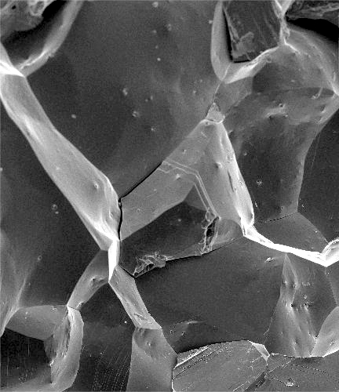

Fracture surface of polycrystalline low-alloy ferrite steel: the fracture was induced by grain boundary segregation of phosphorus.

Ab initio DFT simulations of the mechanical, transport and chemical properties of nanostructures

Based on performed ab initio DFT (Density Functional Theory) simulations [1-4] we have unveiled new possibilities controlling the catalytic reactions of metallic nanocontacts as well new applications of nc-AFM (non-contact Atomic Force Microscope) method in surface science. Namely we have predicted the enhanced chemical reactivity of gold mono-atomic chains inducing the dissociation process of hydrogen molecules on the gold chains [1] accompanied by a decrease of the conductance in a good agreement with published experimental data. Hereafter the simulations have pointed out the strong dependence of the chemical reaction on the applied mechanical stress, which opens up the new way to control chemical reactions on/of nanosystems.
We have developed a simple analytical model describing interaction of a AFM tip with surfaces based on performed ab initio simulations and experimental data enabling the chemical identification of individual atoms using the atomic force spectroscopy [4]. Ab initio simulations have also served to elucidate the origin of the dissipation process and the adhesion forces [2] obtained by nc-AFM technique.

  - P. Jelínek, R. Pérez, J. Ortega, and F. Flores: Hydrogen dissociation over Au nanowires and the fractional conductance quantum; Phys. Rev. Lett. 96: 046803 (2006).
  - N. Oyabu, P. Pou, Y. Sugimoto, P. Jelínek, M. Abe, S. Morita, R. Pérez, and Ó. Custance: Single atomic contact adhesion and dissipation in dynamic force microscopy; Phys. Rev. Lett. 96: 106101 (2006).
  - Y. Sugimoto, P. Pou, Ó. Custance, P. Jelínek, S. Morita, R. Pérez, and M. Abe: Real topography, atomic relaxations, and short-range chemical interactions in atomic force microscopy: The case of α-Sn/Si(111)-(sqrt[3]xsqrt[3])R30º surface; Phys. Rev. B 73: 205329 (2006).
  - Y. Sugimoto, P. Pou, M. Abe, P. Jelínek, S. Morita, R. Pérez, Ó. Custance: Atomic force microscopy based single-atom chemical identification; Nature, accepted.

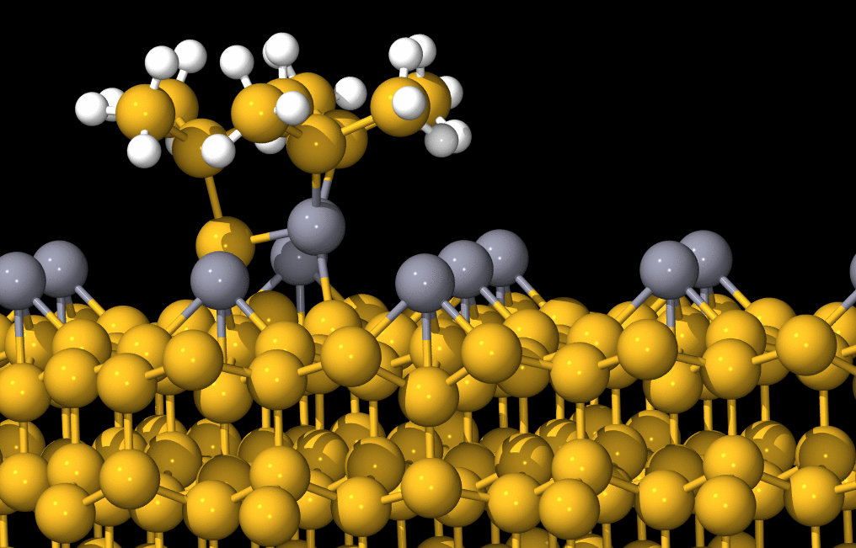

The stick-and-ball model of an optimized atomic structure obtained from the ab initio calculation of the interaction between the nc-AFM tip and Sn/Si(111) surface. Here, the yellow balls represent silicon atoms, the gray and white balls are tin hydrogen atoms respectivelly.

Hardness of covalent and ionic crystals

The empirical equation was discovered to calculate hardness of covalent and ionic materials. The parameters in the equation are determined by electron distribution in a crystal using first principle calculation. The results based on ab initio calculations of electron states of more than thirty crystals show very fine agreement with the experimental data (from very soft materials as rock salt to superhard ceramics and diamond). As a consequence of the explicit form of the equation was also found an unexpected result that contradicts conventional wisdom: atoms surrounded by relatively few other atoms -- that is, those having a lower "co-ordination" number -- are harder than those surrounded by lots of other atoms.
The equation makes it possible to predict hardness of structural models of hypothetical crystals that is important for the quest of new superhard materials and material research in general.

A.Šimůnek, J.Vackář: Hardness of covalent and ionic crystals: First-principle calculations, Phys. Rev. Lett. 96: 085501 (2006).

Upper limit on primary photon fraction in cosmic rays with energies above 10 EeV

The origin of cosmic rays (CR) at very high energies encountering the Earth with energies above 10 EeV ranks among the least understood phenomena of contemporary physics. The newly built hybrid detector - Pierre Auger Observatory in Argentine was employed to determine the fraction of very-high-energy photons in the primary CR. One of its basic components is the fluorescence detector, which was designed and built with the strong participation of the team of specialists from the Institute of Physics who developed and constructed the optical system of the telescopes.
In addition to this a small robotic telescope was devised and build in the Institute of Physics to measure the key parameters of the atmosphere. Their precise knowledge is essential for the elimination of the influence of the atmosphere on the CR atmospheric shower profiles and the subsequent energy reconstruction. Analysis of the data obtained by the fluorescence detector allowed the international team of the Observatory to determine the photon fraction upper limit for energies above 10 EeV. The fraction is lower than 16% at the confidence level of 95%. It is the first ever measurement based on the analysis of the fluorescence profile of the atmospheric CR showers and thus refines the current results obtained by the surface detectors of the previous experiments Haverah Park and AGASA. Moreover, the newly determined photon upper limit serves as an important credibility criterion for various hypotheses about the origin of very-high-energy CR.

L. Abraham, ... M. Boháčová, M. Hrabovský, D. Mandát, L. Nožka, M. Palatka, M. Pech, M. Prouza, J. Řídký, P. Schovánek, R. Šmída, P. Trávníček: FERMILAB-PUB-06-210-A, Jun 2006. 29pp., e-Print Archive: astro-ph/0606619; Astropart. Phys., v tisku.

Applications of X-ray laser for generation and probing of dense plasmas

Currently the most powerful soft X-ray laser has been developed at PALS delivering 10 mJ pulses at 21 nm. The X-ray laser beam was focused to a homogeneous spot with diameter of 20 μm using a spherical mirror with a Mo:Si multilayer coating. The energy density within the focal spot was in excess of 50 Jcm⁻², which corresponds to radiation peak intensity of 10¹² Wcm⁻² [1]. Such a high energy density of X-ray radiation cannot be achieved by any other existing experimental technique. It has made it possible to perform unique experiments e.g. on material ablation of solids and generation of isochorically heated solid density plasmas relevant to laboratory astrophysics.
For the first time, it was experimentally demonstrated that the X-ray laser can be used to measure precisely the opacity of hot, dense iron plasma [2]. Opacities are very important in radiation diffusion models of the Sun and other stars. The temporal evolution of the opacity of an iron plasma at high temperature (30–350 eV) and high density (0.001–0.2 gcm⁻³) has been measured using a nickel-like silver X-ray laser at 13.9 nm. The iron plasma was created in a thin (50 nm) iron layer buried 80 nm below the surface in a plastic target that was heated using a separate infrared laser, and then probed by a collimated X-ray laser beam. The agreement of opacity modelling with the experimental X-ray laser transmission data shows the importance of considering a large number of bound-bound transitions in the calculation of the opacity of the hot dense iron plasma.

[1] T. Mocek, B. Rus, M. Stupka, M. Kozlová, A. R. Präg, J. Polan, M. Bittner, R. Sobierajski, L. Juha: Focusing a multimillijoule soft x-ray laser at 21 nm; Appl. Phys. Lett. 89: 051501 (2006).

[2] M.H. Edwards, ... B.Rus, T. Mocek, M.Kozlová: Opacity measurements of a hot iron plasma using an x-ray laser; Phys. Rev. Lett. 97: 035001 (2006).

