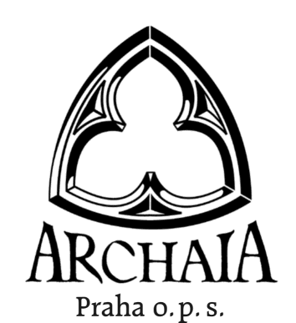

ARCHAIA Praha, o. p. s.

cordially invites you
to the conference

FORUM ARCHAEOLOGIAE POST-MEDIAEVALIS

Written and iconographic sources
in post-medieval archaeology
(main topic)

which will be held in Prague
on March 23-24, 2010

Program:

Tuesday, March 23 10.00-10.15 opening of the conference
10.15-13.00 papers and discussions (main topic)
13.00-14.30 lunch
14.30-17.30 papers and discussions (main topic, others)
17.30- dinner

Wednesday, March 24 9.00-12.00 papers and discussions
12.00-13.30 lunch

Working languages: Czech, English.

We kindly ask you to fill in the enclosed registration form and to send it to the following address by the end of December 2010:
Archaia Praha, o. p. s.
Jaromír Žegklitz
Truhlářská 20
110 00 Praha 1
Czech Republic
e-mail: zegklitz@archaia.cz

All the necessary detailed information will be sent after the registration acceptance deadline.

We are looking forward to your reply.

Yours sincerely,
Vojtěch Kašpar
Jaromír Žegklitz

Registration form

Name:
Surname:
Organization:
Address:
e-mail:
I would like to register the paper – for the main topic yes/no
– other yes/no
– none
Title of the paper:

Abstract of the paper (up to 20 lines):

Paper delivery duration should not exceed 20 minutes.
Delivered papers will be published in the volume Studies in Post-Medieval Archaeology 4.

I will require some of the following equipment: - data projector yes/no
- slide projector yes/no
- overhead projector yes/no
- other (please specify)

I will require accommodation - from March 22 to March 23 yes/no
- from March 23 to March 24 yes/no
- from March 24 to March 25 yes/no

The costs for accommodation (speakers) and the evening meal on Tuesday will be covered by the organizers.

The participant's fee of EUR 30 (speakers EUR 15) will be covered
- at the presentation
- by February 29, 2008 via bank transfer to the account no. 182850830/0300, ČSOB, náměstí Republiky 7, Prague, IBAN CZ6903000000000182850830.

