CONFERENCE

TOPICAL PROBLEMS OF FLUID MECHANICS
Prague, February 25, 2004

 | Department of Technical Mathematics  Faculty of Mechanical Engineering  Czech Technical University in Prague | The aim of the conference is to discuss contemporary problems  of fluid mechanics and to bring out latest results obtained  in the course of solution of grant projects supported by Grant Agencies in Czech Republic and abroad. The attendance  of experts from the academician institutes, technical universities and from the other research institutions is assumed.  For the detailed information including the registration form and scientific programme see the conference web page:  www.it.cas.cz/~ercoftac/index.html
 | Institute of Thermomechanics  Academy of Sciences of Czech Republic
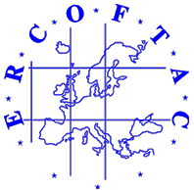 | European Research Community  On Flow, Turbulence  And Combustion
Yours sincerely,
Organizing Committee
Prof. Jaromír Příhoda  Institute of Thermomechanics AS CR  Czech ERCOFTAC Pilot Centre | Prof. Karel Kozel  Dept. of Tech. Mathematics  Faculty of Mechanical Engineering  CTU Prague

