SECOND ANNOUNCEMENT

5. česko - polská konference
“GEOLOGIE HORNOSLEZSKÉ PÁNVE”

5. czesko - polska konferencja
“GEOLOGIA ZAGŁĘBIA GÓRNOŚLĄSKIEGO"

5th Czech and Polish Conference
“GEOLOGY OF THE UPPER SILESIAN BASIN”

Ostrava, Czech Republic
November 6. - 8. 2002.

Scientific Committee

M.Dopita
R.Gradzinski
A. Kotas

I.Lipiarski

J. Pešek

M.Sivek
I. Sýkorová
A. Zdanowski

Organizing Committee

M. Doktor
P. Konečný, jr.
A. Kožušníková
P. Martinec

Technical Committee

- Kolcún
K. Marečková
D. Nováková
J. Ščučka
M.Vavro

REPLY FORM

NAME: ______________________________________________________________

MAILING ADDRESS: _________________________________________________

_____________________________________________________________________

TEL: ________________________, FAX: ___________________________________

E-MAIL: _____________________________________________________________

REGISTRATION FEES:

Participant | 1250CZK/35US$ | ______________
Accompanying person | 450CZK/15US$ | ______________

ACCOMMODATION DATE PRICE

First class hotel
1bed room | since______ | to________ | 810CZK/27US$/night | ________
2 beds room | since______ | to________ | 660CZK/22 US$/night | ________
Students residence
1bed room | since______ | to________ | 360CZK/12US$/night | ________
2 beds room | since______ | to________ | 210CZK/7US$/night | ________

TOTAL |  |  | CZK/US$ | ______________

Instructions for authors of paper to Proceedings:

The text (in Czech, Polish or English) of the final publication (including abstract) should be sent on 3.5” IBM floppy disc or compact disc together with a printed copy. Please print out cleanly (laser printer or ink jet printer on suitable paper).
The text should be given in WORD format without dividing of words and recoils. Papers should not contain more than 6 pages. In the case of extra pages, please, contact the organising committee. The names of authors with the full addresses should be written below the title of the paper.
The tables and figures should be added as separate files. The tables in Word format and the figures in CDR or TIF format. The photos are required to be in the original. A copy of the picture can be pasted onto page where you want it to appear in the text. Please, write down the name of author and the number of picture on the back of the original copy. The printing will be in black and white only.

References – examples:

Kožušníková A., Martinec P., Pešek J. & Valterová P. (1999): Coal clasts in the Carboniferous sediments of the Upper Silesian basin. - Bulletin of the Czech Geological Survey, 74, 2: pp.109-113, ČGU Praha.
Konečný P. Jr, & Sitek L. (1998): Two technologies of rock samples cutting: Their effect on samples strength properties. – In: Rossmanith (ed.): Proceedings of the third international conference on Mechanics of Jointed and Faulted Rock, Vienna.

The Proceedings of Symposium will be published by PERES Publishers (Prague)

PRELIMINARY PROGRAM

Tuesday, November5

14.00 – 18.00 | Registration

Wednesday, November 6

07.00 – 09.00 | Registration
09.00 – 09.15 | Opening Ceremony
09.15 – 10,15 | Lectures
10.15 - 10.40 | Coffee break
10.40 - 12.00 | Lectures
12.00 – 13.30 | Break for lunch
13.30 - 15.10 | Lectures
15.10 - 15.30 | Coffee break
15.30 – 17.30 | Lectures

Facultative excursion on Institute of Geonics
Welcome party

Thursday, November 7

08.00 – 09.40 | Lectures
09.40 – 10.00 | Coffee break
10.00 – 12.00 | Lectures
12.00 – 13.30 | Break for lunch
13.30 - 15.10 | Lectures
15.10 - 15.45 | Coffee break - Poster section
15.45 – 17.45 | Lectures

Visit of Ostrava town-hall (tower)

Friday, November 8

Field trip

- Důlní průzkum a bezpečnost Paskov
View of drilling core from mines, visit of laboratory
- Mine Paskov
Mine excursion

Travel information

By train:
The nearest train station to the Institute of Geonics is “Ostrava – Svinov“ station. After that it is possible to go by bus no. 37 or you can take a taxi (around 100,- CZK ). The name of bus stop is " Studentská".

By car:
Institute of Geonics is situated in Ostrava – Poruba in the campus of the Technical University – Ostrava (VŠB-TU) and University Hospital – Ostrava. Travel directions will be sent on request.

ORDER (mark desired, payment during registration)

Dinner | 6.11. | 7.11. | 8.11. | (price 40CZK/1)

Excursion 8.11.2002 (Estimated prize 150CZK)

DPB | or | MINE PASKOV (count of participants limited)

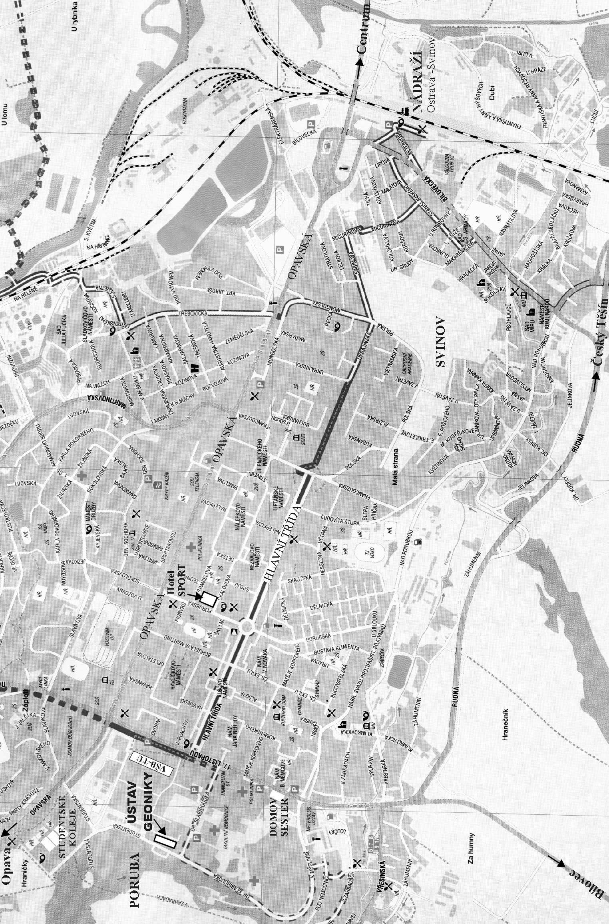
Final papers and fees should not be sent later than on 15th September 2002

Please, transfer the amount of …………………………… US$ in favour of account No: 8406734/0600.

The name of account: Hornická společnost
Pobočka Ústavu geoniky AVČR
Account owner address: Studentská 1768
708 00 Ostrava – Poruba
Czech Republic

Beneficiary′s Bank: GE Capital Bank, a.s.
Havlíčkovo náb. 38A
701 34 Ostrava
Czech Republic

For details, please, contact:
Ing.Alena Kožušníková, PhD.
Institute of Geonics AS CR
Studentská 1768
708 00 Ostrava – Poruba
Czech Republic
Tel: +420-69-6979111
Fax: +420-69-6919452
E-mail : czpk2002@ugn.cas.cz
http://www.ugn.cas.cz

