Abstract template and instructions for annual conference of the Czech aerosol society

John SMITH¹, Petr PLAMÍNEK^{1,2}, Jaroslav WEIS²

¹ First Institute, AS CR, Prague, Czech Republic, email@institute.cz
² Second Institute, City, Country, email@network.com

Keywords: Atmospheric aerosols, Chemical composition, AMS, PM1

INTRODUCTION

The abstract should be in one column (like this example) with lenght 2, 4 or 6 pages. Use A4 page set-up and make following format: top and bottom margin 2.5 cm (0.98 inch), inside margin 3 cm (1.18 inch) and outside margin 2 cm (0.79 inch). Set a portrait orintation, mirro margins and single line spacing (see Figure 1).

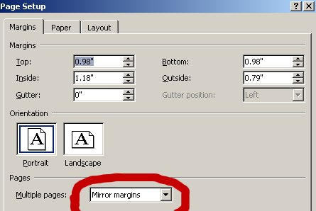
Fig. 1: Page setup in Word.

EXPERIMENTAL SETUP

Use 12 pt Cambria font. Centre the title, the authors’ names, the addresses, keywords and contact email address. Please compose a title that clearly and succinctly describes the content of your work. Ensure that Figures and Tables have captions and that they are numbered consecutively. Start each paragraph with an indent. Justify the body of the text both left and right. Do not use page numbers. Keywords are there to draw attention to your abstract, and to help the organizers allocate the presentation to the most appropriate session.
The text is divided roughly into the following subsections: Introduction, Experimental setup, Results, Conclusions, Acknowledgement and References. Titles of subsections are centered and in All Caps format.

Tab. 2: Table example - diagnostic parameters considered during data flagging.
 | Dresden | Augsburg | Prague | Ljubljana | Chernivtsi
Aerosol flow | 1 lpm | 0.5 lpm | 1 lpm | 1 lpm | 1 lpm
A. temperature | 10-30 °C |  | 10 – 30 °C | 10-30 °C | 10-30 °C
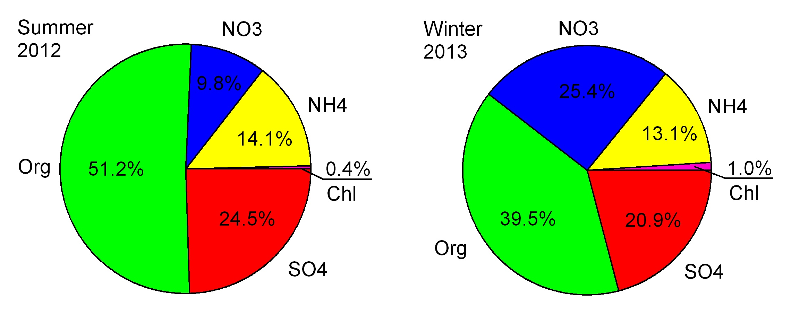Fig. 2: An example of figure - an average relative composition of non-refractory aerosol.

RESULTS AND CONCLUSIONS

Graphs are better like pictures (e.g. jpg, png) then in Excel format (see Figure 2). Font in graphs should be easy to read - not like in Figure 1 but rather like in Figure 2. Instead of use Word drawing, rather export schemes like pictures. Tables are only with horizontal lines. An examle of an equation is here.

$E_{p}\left(d\right)=E_{c}−\frac{4σV}{d}$, (1)

References should be made in the style (Paatero, 1999), Brunekreef and Holgate (2002) or as Liu et al. (1997). Examples of references are shown below.

ACKNOWLEDGEMENT

This work was supported by the Czech Science Foundation under grant P209/11/1342.

REFERENCES

Brunekreef B., Holgate S. T., Air pollution and health, Lancet, 360, 1233-1242, (2002).

Liu, D., Rutherford, D., Kinsey, M., Prather, K., Real-time monitoring of pyrotechnically derived aerosol particles in the troposphere, Anal. Chem., 69, 1808-1814, (1997).

Paatero, P. The multilinear engine – a table-driven least squares program for solving multilinear problems, including the n-way parallel factor analysis model. J Comput Graph Stat. 1999;8:854–888.

