Supplementary material Fig. S1. Land use and suitable habitat (SH) of each country along the shared border with Bulgaria.
COUNTRY BORDER | LAND USES FOR WILD BOAR ALONG BULGARIA’S BORDERS WITH OTHER COUNTRIES | SUITABLE HABITAT (SH) FOR WILD BOAR ALONG BULGARIA’S BORDERS WITH OTHER COUNTRIES
Bgr-Gr | 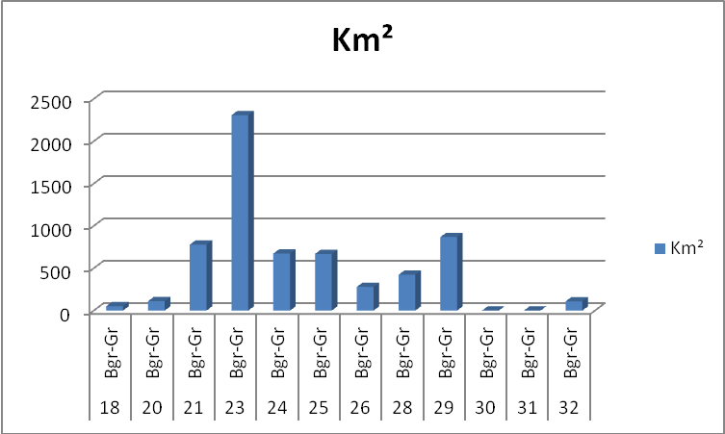 | 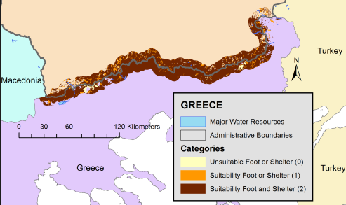
Bgr-Mac | 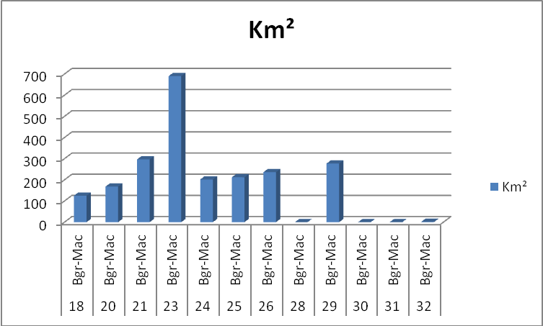 | 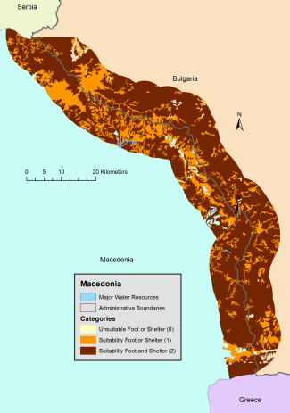
Bgr-Rom | 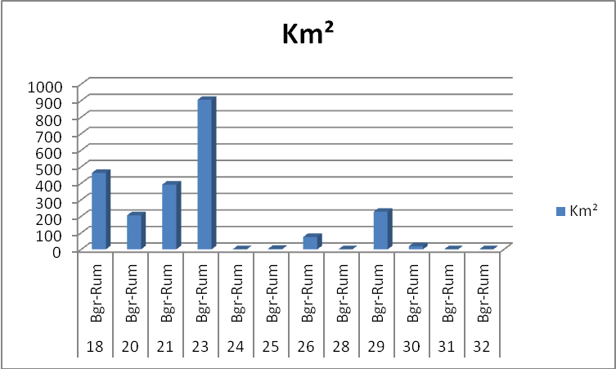 | 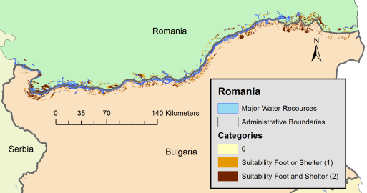
Bgr-Serb | 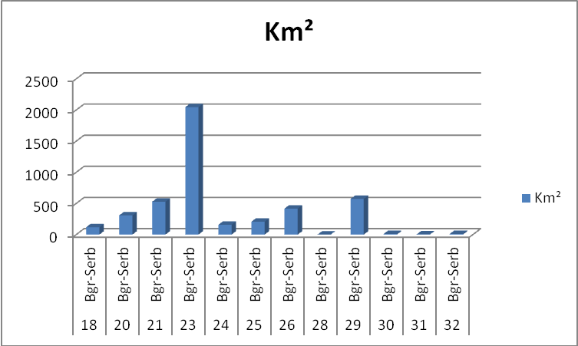 | 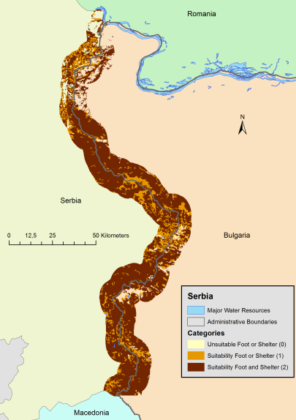
Bgr-Tur | 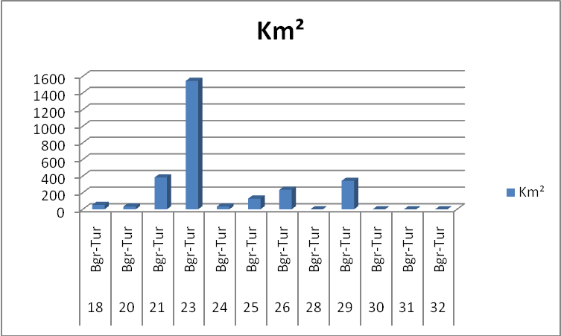 | 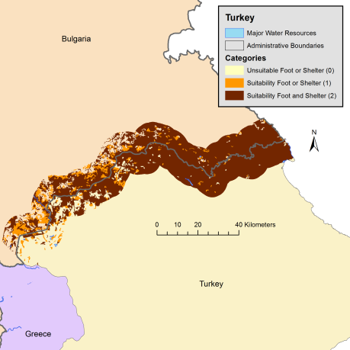
Legend |  | 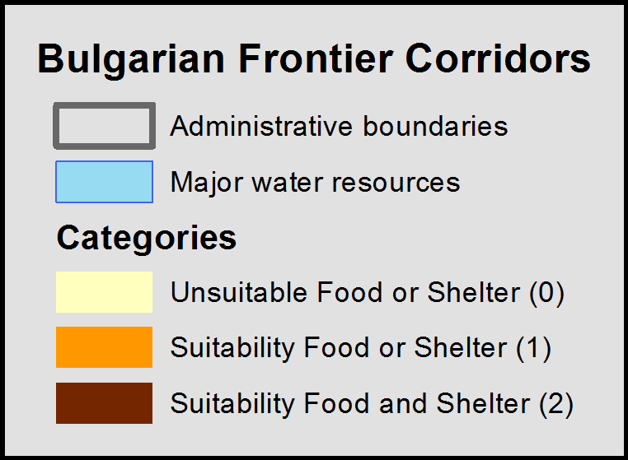
  GRIDCODE | LABEL
  18 | Pastures
  20 | Complex cultivation patterns
  21 | Land principally occupied by agriculture, with significant areas of natural vegetation
  23 | Broad-leaved forest
  24 | Coniferous forest
  25 | Mixed forest
  26 | Natural grasslands
  28 | Sclerophyllous vegetation
  29 | Transitional woodland-shrub
  30 | Beaches, dunes, sands
  31 | Bare rocks
  32 | Sparsely vegetated areas

