8th European Symposium on Martensitic Transformations
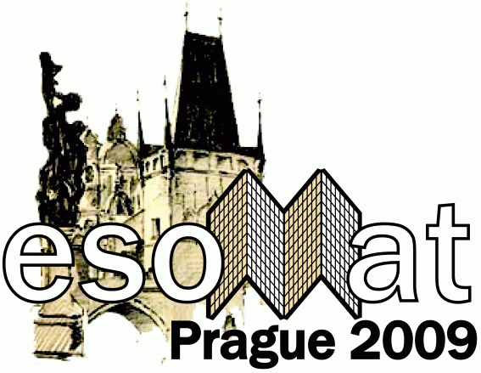
ESOMAT 2009

September 7-11, 2009
Prague, Czech Republic
esomat@fzu.cz

Proposal form for Announcement for Esomat 2012 conference

ESOMAT 2012 proposer (person and institution):

Further institution(s) involved:

Conference Title: The 9th European Symposium on Martensitic Transformations ESOMAT 2012

Date:

Venue:

ESOMAT 2012 Chairmen (s):

Further comments to the event organisation:
- number of participants expected
- accommodation
- dining
- WiFi internet
- Conference scientific program
- Conference social program
- etc.

Scientific programme:

Local organizing committee:

Conference schedule:

Registration fee: will cover
- Rent of the conference rooms, technical equipment
- etc.
- ..
Other relevant issues:

This form shall be filled, signed by the conference proposer with institution stamp and sent till April 15, 2009 by mail (email, fax) to:

Dr. P. Šittner
ESOMAT 2009 chairmen
Institute of Physics of the ASCR, v.v.i.
Na Slovance 2, 182 21 Prague 8
Czech Republic
Fax: (+420) 286 890 527
E-mail: esomat@fzu.cz

