10th Central European Workshop on Soil Zoology

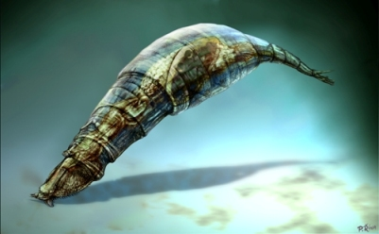
CEWSZ - 10
České Budějovice, Czech Republic, April 21-24, 2009

Instructions to Authors

Manuscripts have to be in English (we urgently recommend to have them reviewed by a native speaker familiar with the field) and must not exceed 12 (lectures) or 8 (posters) pages including figures, tables and references. Manuscripts must be written in MS Word, in Times New Roman (12 pitch font size), with double spacing on A4 format pages (210 x 297 mm). They shall be submitted either in person during the Workshop or by e-mail or by mail on a CD (if necessary).

Manuscripts should be generally organised in the following order:
Title (should be clear, descriptive and not too long)
Full name(s) of author(s)
Complete postal address(es) of affiliations, incl. e-mail addresses
Abstract
Keywords (3-6 items)
Introduction
Material and methods
Results
Discussion
Acknowledgements
References
Tables
Figure captions

Figures must be submitted in Excel (graphs) or in jpg or bmp versions (not in Corel or Statistica formats).
All papers cited in the text [ Dryden (1986); (Lattin, 1997); Kumari and Nair (1967); Tamiro et al., 1990) ] should be given in the list of references. References to unpublished works should be kept to a minimum. References to published works should be listed according to the following examples:
Periodicals:
Dryden, C.A., 1986. Growth and development of Lumbricus rubellus in artificial soil. Soil Biol. Biochem., 28: 2-15
Books:
Donner, J., 1965. Ordnung Bdelloidea (Rotatoria). Akademie-Verlag, Berlin, 297 pp.
Work in an edited collection:
Tamiro, A.K., Standen, Z., Ingus, Z., 1990. Soil structure and soil moisture. In: Stewart. B.A. (ed.), Soil physical parameters. Proc. Int. Conf. Soil. Sci., Prague, p. 129-155

Illustrations and their captions or legends must form a separate unit. References to illustrations and tables in the text are to be given as follows: Fig. 1, Figs. 1-2, Table 1.
Latin names of the taxa (up to genus) should be typed in italics.

Manuscripts must be submitted before September 1, 2009,
however, earlier submission will be highly appreciated.

