Testing of pores in nanofiber web

Jakub Hrůza
Department of Nonwovens, Textile Faculty, Technical University of Liberec

Introduction:
The gas and liquid filters containing nanofibres have been described in a number of patents and papers. Filtration efficiency is closely related to the fiber diameter. Electrospinning technology is able to produce fibers with diameter in submicron range and created materials can filter off dangerous bacterias and viruses but also the tobacco smoke. The technology of the industrial nanofiber manufacturing was developed at the Technical University of Liberec, Department of nonwovens. The nanofiber materials used for filtration are: polyvinylalcohole (PVAL) and polyamide (PA).
The greatest advantage of nanofibers is the rapid increase of the filtration efficiency with less significant decrease of the filtration permeability or less significant pressure drop derived from the filtration permeability. Here are three serious arguments for this statement:
At first: High specific surface of nanofibers improves the process of the particle capture. In terms of the deep filtration the particle capture is given by interaction between particles and fiber surface. It is important that for fiber diameter less than 1 micrometer the relative surface increases very intensively [1].
At second: Boundary conditions of the flow around the submicron fibers, which are different compared to other fibers. These conditions are called “slip flow” [2]. Due to slip flow the drag force decrease and the captured particles are carried more close to the fiber surface.
At third: The pores in nanofiber web are very small. Thus all particles bigger than pores are captured on the filter surface due to filtration mechanism named “sieve effect” [3]. This argument is very importatnt for liquid filtration where the sieve effect is more important then mechanisms of deep filtration.

Sieve effect and pore size
Sieve effect is very important filtration mechanism especially for cleanable filters and for liquid filtration. Cleanable air filters are used in various industrial applications such as power stations, cement factories, heating plants etc. with a vast amount of impurities or in applications such as spray boxes where high efficient filters are necessary. Most of the dust is collected on the surface of filters. When the increasing pressure drop reach a set value, the filters are cleaned by a short burst of compressed air moving in reverse direction. For liquid filtration is sieve effect more important because the other filtration mechanisms depend on the inter-surface interactions and these interactions decline with bigger filtered medium viscosity.
Pore size is the main parameter, which determine sieve effect of the filter. All particles bigger than the biggest pore size will be captured on the filter surface.

Methods of pore size testing
It is very difficult to define the pore shape. Pore is a space among the fibers and it´s shape depends on the textile structure. The nanofiber web made by “nanospider method” is very thin web with areal isotropis structure. For filtration application of this web is suitable to assume the pore as the incircle among the fibers.
Various methods of pore size testing are known. Direct method of testing is image analyzis of microscopic picture of web. As indirect methods are: sifting of defined size particles through the web and methods based on the surface tension between the web and the liquid penetrated inside (wetting agent). The simpliest surface tension metod named “Bubble point method” (see fig. 1) allows testing the maximum pore size and after modification estimating the mean pore size.
Bubble point method tester was created in Department of nonwovens ten years ago. This test device has been modificated to be able to test very small pores (less than 1 μm) and to test mean flow pore size.
Fig. 1: Principle of the bubble poin method. The pressure of the air expel the wetting agent and the air goes through the biggest pore when both forces are equal (γ is surface tension of wetting agent). The pore is assumed as the circle.
D
F_{γ} = γ . π . D
F_{p} = p . S
textile sample
wetting agent
bubble

Experiment
Maximum and mean pore size of two different nanofiber webs were tested by two methods. At first were tested directly by image analysis and at second by the modificated bubble point method. For tests were prepared two different samples (see tab.1). Tested samples differed in material, area density and fiber diameter to examine if the bubble point test method is valid for this type of membrane. The first sample “A” was prepared from polyurethane (PU) nanofibers placed on the woven sublayer. The second sample “B” was prepared from the polyamide 6 (PA 6) placed on the meltblown sublayer. Both samples were prepared for air filtration application.

Parameters | Tested samples
 | A | B
Material | PU | PA 6
Supporting sublayer | woven textile; PET | meltblown textile; PP
Nanofiber area density | 1,5 g/m² | 0,9 g/m²
Nanofiber diameter | mean value: 293 nm;  median: 236 nm;  standard dev. 207 nm | mean value: 63,0 nm;  median: 59,8 nm;  standard dev. 14,3 nm
Nanofiber thickness | 25 μm | 18 μm
Tab. 1: Parameters of tested samples.

Test results:

Image analysis method:
For the direction test of mean and maximum pore size by image analysis were used pictures obtained from electron microscope (see fig. 2 and 3). It is difficult to decide which fibers are conected together and consequently where are real pores. The real structure is 3D thus due to conversion to 2D space the test results depend on the subjective visualisation. The space between the fibers was filled by 2D ellipse with 2 as a maximum ratio between axes. The test results are shown in tab. 2.

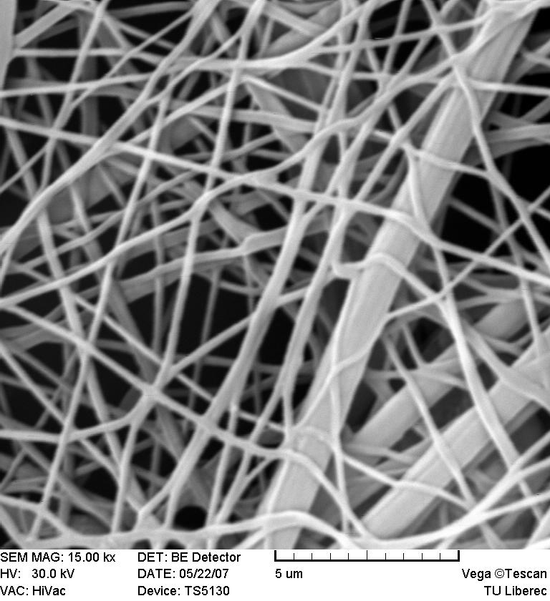 | 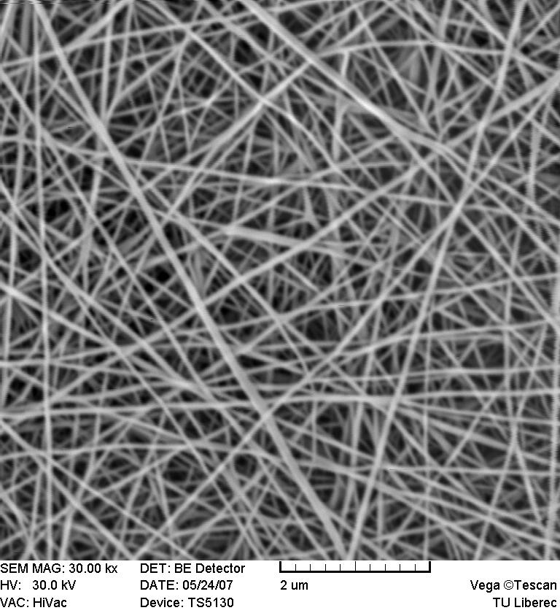
Fig. 2: Tested sample A | Fig. 3: Tested sample B

Bubble point method:
The bubble point method to test maximum and mean pore size was realized according to ASTM F 316 standard. The sample size was 17,3 cm² as tested liquid was used mineral oil with surface tension 34,7 mN/m. The test results are shown i tab.2.

Pore size | Image analysis method |  |  | Bubble point method
Pore size | mean value (μm) | standard deviation (μm) | maximum value (μm) | mean value (μm) | standard deviation (μm) | maximum value (μm)
Sample A | 2,22 | 0,82 | 3,51 | 10,1 | 0,41 | 25
Sample B | 0,21 | 0,077 | 0,35 | 5,2 | 0,14 | 12
Tab. 2: Test results of pore size tests.

Conclusion:

The comparison between two used methods is not very successful. The values obtained from image analysis are lower than the values obtained from bubble point test device. The lack of image analysis was described above. This is problem with 2D projection of complicated 3D porous object. Moreover when we use image analysis method it is possible to test only very small part of the nanofiber web. When we test bigger surface of the sample it is more probable that the size of the biggest pore will be bigger.
When we use the bubble point method to observe pore size the problem is different. The high pressure (around 40 kPa) of the air changes the structure of nanofiber layer. The weak nanofibers are moved and the pores are bigger. It is probable that this problem will be solved with new type of nanofiber sublayer.

References:

[1] HRŮZA, J., POLÁCHOVÁ, J: Respirator filters with nanofibers. AUTEX, University of Maribor, Portoroź Slovenia 2005.Page 149-154. ISBN 86-435-0709-1
[2] BROWN, R. C.: Air filtration. 1st edition. Sheffield, 1993. ISBN 0 08 041274 2
[3] WAKEMAN, R.J., TARLETON, E.S.1999: Filtration. First edition. Elsevier Advanced Technology 1999. ISBN 1 85617 345 3.

Acknowledgment

This contribution was supported by the grant 1M4674788502 (Pokročilé sanační technologie a procesy).

