Institute of Philosophy,
Czech Academy of Sciences 22 July 2009

To Whom It May Concern:

New Financial Arrangements for Czech Academy of Sciences
News of the recent budgetary plans for the Czech Academy of Science have caused considerable alarm among many senior academics in the U.K. Of particular concern is the threat the new financial strategy poses to the successful functioning of the Institute of Philosophy in Prague – for so long a beacon of high academic standards and international cooperation.
For many years now, the re-emergence of important intellectual traditions in central Europe have been spearheaded by efforts of philosophers of the Czech Academy of Science. Not only have they played the leading role in forging successful links and partnerships with academics in the U.S. and Western Europe, they have also established the Czech Republic as the lead player when academics from those countries are looking for partners in international research networks.
Networks created as a result of the industriousness of the philosophers in Prague should not be minimized. These have produced great benefits to academics throughout the world, who have been regular participated at international conferences in Prague, and other centres, and who have subsequently published in Czech journals. As a result of these collaborations, a new generation of young Czech philosophers have been able to visit top universities around the world as part of their research training, and, instead of seeking jobs abroad, they have returned to the Czech Republic to continue the developing trend towards international research excellence.
It is no exaggeration to say that the volumes of published papers arising from colloquia involving some of the world’s most highly respected philosophers, including P.F. Strawson, W.V. Quine, Donald Davidson, Hilary Putnam, and John Searle, continue to exert a powerful influence on the Anglo-American tradition; thereby continuing to promote the influence and prestige of the Czech Academy of Sciences on the world stage.

It is understandable that strict budgetary measures have to be taken as a result of the current financial crisis, and that priority must be given to research excellence and economic impact. However, care must be taken not to damage the current high standing and international reputation of the Czech Academy. Their reputation of Czech philosophers rests on the quality of their contributions to the study of logic and language: areas of philosophical concern that have also had a huge impact on the fields of computer science and communications.
The existing renown of the Czech philosophical community and its role in maintaining the high international reputation of the Czech Academy of Sciences should not be put at risk. The prestige and impact of such an international reputation, and the benefits it brings to the country, not only in terms of perception, but also in economic terms, is easy to miss when taking short-term measures. However, in the long-term, the ability to retain outstanding researchers, develop a highly-skilled and well-educated population, to participate in international networks, and to secure European research grant income depends on these intellectual assets. They must be secured and strengthened if the Czech Academy is to have a place in the world rankings.
Yours truly,
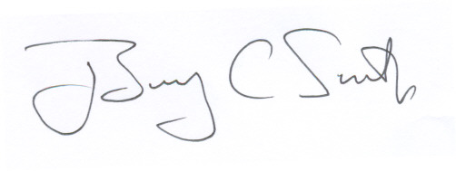
Prof Barry C Smith,
Professor of Philosophy,
Director of the Institute of Philosophy,
School of Advanced Study
University of London

