STRATIFIED FLOW MODELLING

Aleš Jirk, Josef Brechler
Charles University, Faculty of Mathematics and Physics, Department of Meteorology and Environment Protection, Prague

1. Introduction
In this presentation the results of 2D stratified, laminar Flow in a cavity and around a square obstacle modelling are presented. The flow is characterized with the Reynolds number Re defined as UL/ν where ν is the kinematic viscosity, U is the incoming flow speed and L is the characteristic size (the length of side of the square cavity or the size of the obstacle). Next characteristic number is the Froude number Fr = U²/(gL), g is the acceleration of gravity. This number determines the stability of the stratified flow (rate between the buoyancy and the inertia force) and it is the inverse of the Richardson number Ri. For Ri in the range 0,1 – 10,0 both forces contribute to the flow structure and the flow can be considered as mixed convection (MOHAMED, VISKANTA, 1995).
In this work there are simulated two cases. The first one is a lid-driven cavity with influence of stratification. The second case is a stratified flow past a square cylinder.
2. Model equations
The influence of stratification in the momentum equation is described with the Boussinesq approximation. The equation for the potential temperature perturbation is added to the governing system (non-dimensional form), (JIRK, 2008):
$\frac{∂v_{i}}{∂t}+\frac{∂v_{i}v_{k}}{∂x_{k}}=−\frac{∂p´}{∂x_{i}}+\frac{1}{\text{Re}}{Δv}_{i}+\frac{1}{\text{Fr}}\frac{θ´}{\overline{θ}}$, (1)
$\frac{∂v_{i}}{∂x_{i}}=0$, (2)
$\frac{∂θ´}{∂t}+v_{k}\frac{∂θ´}{∂x_{k}}=−v_{2}\frac{∂\overline{θ}}{∂x_{i}}$, (3)
where t, x_{i} and v_{i} have their usual meaning, θ‘ is the potential temperature perturbation and $\overline{θ}$ is the domain mean of the potential temperature.
The governing system (1-3) is solved by the finite volume method. The advection terms are reconstructed by WENO scheme and the time evolution is solved by application of the explicate TVD Runge-Kutta scheme.
3. Results
3.1. Lid-driven cavity with influence of stratification
Results (the magnitude of velocity $\vec{v^{2}}$ and streamlines) of the stratified cavity flow ($\overline{θ}=0$on the bottom boundary and $\overline{θ}=1$ on the uppermost boundary) are shown for Re equal to 100 and Fr 1,0; 0,1 and compared with result published in IWATSU et al., 1992 and IWATSU, HYUN, 1995.

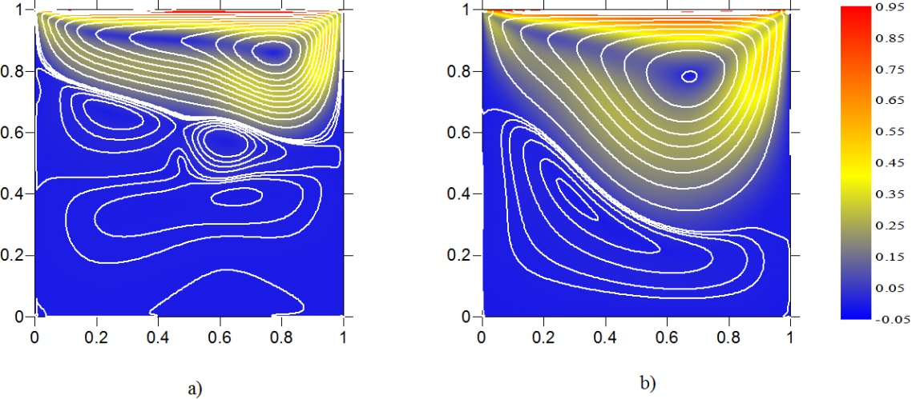
Fig. 1 – Plot of velocity and field of flow a) Fr 0,1 b) Fr 1
On both Figs (1a and 1b) it is possible to see the impact of stability that is stronger in the case when Ri is larger (Fig. 1a).
3.2. Stratified flow past a square cylinder.
On Fig. 2 the results of flow past a square cylinder are shown for Re 200 and Fr 1,00; 0,01.
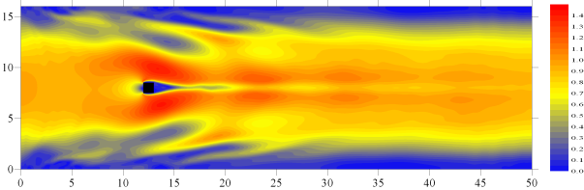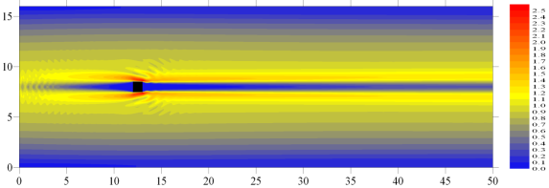
- b)
Fig. 2 – Plot of velocity and field of flow a) Fr = 1, b) Fr = 0,01
The results shown on the Fig. 2 correspond to the hypothesis that with Fr decrease the mixing within the flow field increases. The von Kármán vortex street is not well pronounced (Fig.2b) and the gravitational waves are effused from the cylinder.
ACKNOWLEDGEMENT
This research was supported by the Czech Ministry of Education, Youth and Sports in the framework of the research plan MSM0021620860.
Literature
Ghia, U., Ghia, K. N. and Shin, C. T., 1982. High-Re Solutions for Incompressible Flow Using the Navier-Stokes Equations and a Multigrid Method. Journal of Computational Physics 48, 387-411.
Iwatsu, R. a Hyun, J., M., 1995. Three-dimensional driven-cavity flows with a vertical temperature gradient. Int. Journal Heat Mass Transfer. Vol 38, No.18.
Iwatsu, R., Hyun, J., M. and Kuwahara, K., 1992. Mixed convection in a driven cavity with a stable vertical temperature gradient. Int. Journal Heat Mass Transfer. Vol 36, No.6.
Jirk, A., 2008. Thermally stratified atmospheric flow modelling. Diploma thesis. Dept of Meteorology and Env. Protect., MFF UK Prague (in Czech).
Mohamad, A., A. and Viskanta, R., 1995. Flow and heat transfer in a lid-driven cavity filled with a stably stratified fluid. Applied Mathematical Modelling, vol. 19.

