IRWIN PROBE CALLIBRATION AND ITS USE AT INVESTIGATION OF PEDESTRIAN WIND CONDITIONS IN VICINITY OF HIGH BUILDINGS

Milan Jirsák, David Zacho, Petr Michálek, Kateřina Jandová,

The Aeronautical Research and Test Institute, plc., Prague

1. Introduction
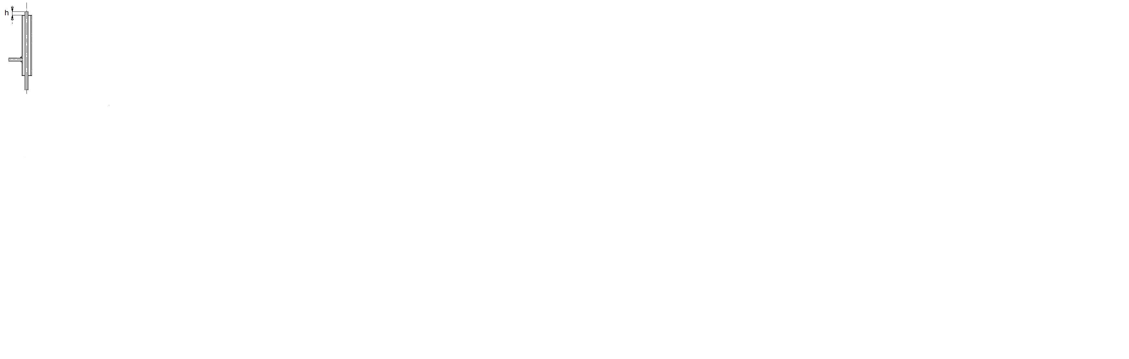
Irwin probe is an effective tool covering requests of pedestrian wind modelling for wind comfort criteria application. This multidirectional probe consists of two concentric tubes where
smaller one protrudes above ground level where the outer one is ended. Pressure difference between both tubes arises in flow, being measured and recorded for statistical evaluation. Simple manufacturing of the probes affords mounting them on all inspected points, where the probes are simultaneously active, giving signals consequently recorded at different wind azimuths.
Mean values and standard deviations of the records enter then own evaluation of pedestrian wind comfort with connection of meteorological data proper to the site. Here some system of wind comfort criteria is applied. Through calculation of probable time per cent of overcoming effective wind gust velocity for given point, a classification table of the criteria gives answer a question, whether the specific re-
Fig. 1 requirement of pedestrian wind comfort proper to category of human activity as it is
intended for the point will be satisfied.

It is not difficult to keep simple geometry of Irwin probe up for nearly uniform static response. Calibration can be done for only selected reference points to apply its averaged result on all measured points at processing. A thermoanemometer is accepted as adequately precise mean for the calibration, with vertically oriented wire and with HW probe adjusted individually to local direction of mean flow above each reference point.
The contribution surveys above all some tested features of Irwin probe. Following main attention is focused to attempt to precise the calibration by restriction of directional sensitivity effect of HWA probe and by optimization of the signal filtration. As an appendix, some IRP applications on experiments with buildings are demonstrated. The first is focused on wind effects near the windward facade of building, the second on wind conditions in passage between two identical buildings with common axis parallel to oncoming wind.

2. Wind tunnel. Approaching flow. Instrumentation

All measurements described in the contribution were carried out in VZLÚ boundary layer wind tunnel (with cross section of 1800 x1500 mm and test section length of 17 m) at boundary layer arrangement with roughness length of z₀= 0,46 mm (it corresponds to z_{o}= 0,15 m in full scale). Mean velocity and turbulence intensity profile is plotted on Fig. 2. Model space was of smooth bottom, where flow accelerated on pedestrian level, so impacting the building models.
The accelerated BL was checked in empty model space, result for mean velocity profile (above the turntable centre) is in graphical form included in Fig. 4.
Honeywell DC001NDC4 pressure sensors with working range of 250 Pa were used for monitoring of the pressure signal at sampling frequency of 3 kHz and T=30 s total time, consistent to the requirement of one hour observation on pedestrian level on prototype [1], [3].

Fig. 2 Equilibrium boundary layer on model section entrance

The pressure signal changed to voltage was low pass filtered by 300 Hz analog filter. Additional digital filtering was performed at final processing. Its nominal cut off frequency of 50 Hz is used at current actions in the VZLÚ boundary layer wind tunnel.

3. Irwin probe response
Theoretical development of Irwin probe pressure response and its similarity is introduced thoroughly in [1], including arguments for signal filtration. Presented experiments had main aim in improvement of IRP current application with respect of possibility of its different probe adjustment, signal filtration and questions of calibration performed on selected reference points.

2.1 Influence of the IRP height.
In general, the height of the central tube h need not correspond to scaled pedestrian height according [1] (it is taken as 1.5 m in full scale). It could be chosen by working range of pressure

Fig. 3, 4 Mean differential pressure – probe height dependence

transducer, eventually by Δp sensitivity to velocity changes. A special test of IRP of changeable height was performed, when the IRP was situated on smooth surface on 1 m distance behind the
roughness field. Nearly logarithmical dependence of Δp on the h was obtained for three reference velocities, see Fig. 3, 4. Expression of Δp/q₃₀ is regressive increasing also with flow
velocity in tested range (q₃₀ is the mean dynamic pressure on the z=30 mm height, which is proper to height of meteorological measurements on z=10 m level above ground). Dimensionless expression Δp/q₃₀ seems to have its limiting course F(h) quadratic dependent on velocity profile in empty model section with smooth floor, see Fig. 4.

Logarithmical regression of the Δp/q₃₀ (h) dependence for three wind velocities was recalculated then to the normalized pressure sensitivity (e. i. derivative of the normalized pressure difference by wind velocity at h=konst). Its dependence on the tube height h is expressed on Fig. 5. Higher sensitivity at smaller h one could explain by positive influence of ground interference.

Fig. 5 of Δp/q₃₀ sensitivity to mean velocity V as a function of h

Probes were adjusted to high of h=4 mm at following experiments (the central tube had diameters of 2,4/1,5 mm).

2.2 Comparison of IRP and HWA response.
To compare a coarse pressure response of Irwin probe with HWA response, which is used for IRP calibration, both probes were used in highly turbulent flow behind the rectangular obstacle with H=90 mm height and 300 mm width. It was situated perpendicularly to wind tunnel, with a changeable distance Δx from the probe. The distance range included recirculation zone, which ends by a stagnation point at Δx/H ≈4, where results are especially interesting. Pressure signal of IRP was normalized by dynamic head on level of z=90 mm in flow without obstacle and so rooted at the experiment evaluation, while velocities yielded by the HWA were only normalized by U(z=90 mm). Fig. 6. is stint on the final comparison.
Fig. 6. Mean and SD relative response of IRP and HWA

The processed mean values embody almost proportionality over inspected Δx range, whereas standard deviations shows quite uneven result: local drop observed about Δx ≈4,5 h is not caused by any decrease of SD response of Irwin probe in true, but much more violent peak on SD distribution pertained to HWA data. This difference in SD response of both instruments was obtained at this early experiment. However, recent checking has not revealed a substantial error caused by unequal filtration of HWA and IRP signals.

2.3 Calibration analysis.
A basic relation between the IRP differential pressure and instantaneous velocity on pedestrian level V_{pd} is considered by Irwin as
V_{pd} = α + β(Δp)^{1/2} ,
where coefficients α and β are determined by calibration [1]. Considerable savings of memory and time rise at multiply probe application using the straight conversion of pressure mean values and its standard deviations to mean velocity and velocity standard deviations. Author [1] introduced following formulas for the recalculation of these statistic parameters [1]
$\overline{V_{\text{pd}}}=$$α+β{\left(\overline{Δp}−1/4\left({\overline{Δp´^{2}}}/{\overline{Δp}}\right)\right)}^{1/2}$ and ${\left(\overline{v^{2}}\right)}^{1/2}=\left(β/2\right){\left({\overline{Δp´}}/{\overline{Δp}}\right)}^{1/2}$ .
As values α and β coefficients depend considerably on combination of response features of measurement line with local characteristics of measured turbulent flow, values of the coefficients α and β are processed from IRP and HWA data obtained simultaneously in the turbulent flow on reference points. The last are selected with respect of their importance (e.g. they are points and wind angles of supposed highest pedestrian loading). The α and β reference values are averaged and so applied at record processing for all measured positions and wind azimuths. Signals of IRP as well as of HWA probe one have to low pass filter at all the measurements, as it [1] justifies.

Influence of the cutoff frequency on scatter of α and β was one from motivations of the experiment. The next one was possible correlation of the local α and β coefficients with sector of wind angle fluctuations. Certain role should play here directional characteristic of the 55P13 probe having an impact on calibration. Common aim was seen at suppressing scatter of α and β coefficients, or an explaining of its origin, which could be exploitable at choice of reference points for calibration.

2.3.1 Directional oscillations
It is supposed that the variability of α and β coefficients is caused by differences in turbulent characteristic of flow in measurement points. Some discrepancy could be caused by variations on directional characteristic of HWA probe also. Although it is used with vertically oriented wire (with its center on pedestrian level) HWA probe is not fully multidirectional, so it does not represent an ideal etalon for multidirectional IRP. Tab. 1 shows values of velocity error caused by disagreement between Dantec 55P13 probe axis and (fluctuating) flow direction. The errors are fairly small in true.

Tab 1. Influence of wind direction oncoming the Dantec 55P13 probe

Yaw angle ± 30 ° 40° 52° 76°
___________________________________________

Velocity error % 1,85 3 5 10

The directional oscillations were visualized on 5 positions along both axis of building base. The positions were identical with IRP or HWA locations exploited at processing of α and β coefficients for further analysis. The extensive test collected data from 2x5 probe positions in wide and narrow facade vicinity at various wind azimuths. The rectangular building model had dimensions of a= 58 mm, b= 175 mm (base) and H=175 or 350 mm height; wind azimuth was changed with step of 22,5°. Fig. 7 shows an example of visualization performed for aims of the analysis. Axis of HWA probe was adjusted parallel the centre of the sector of oscillation in each point according the pictures, excluding points with excessive oscillation angle.

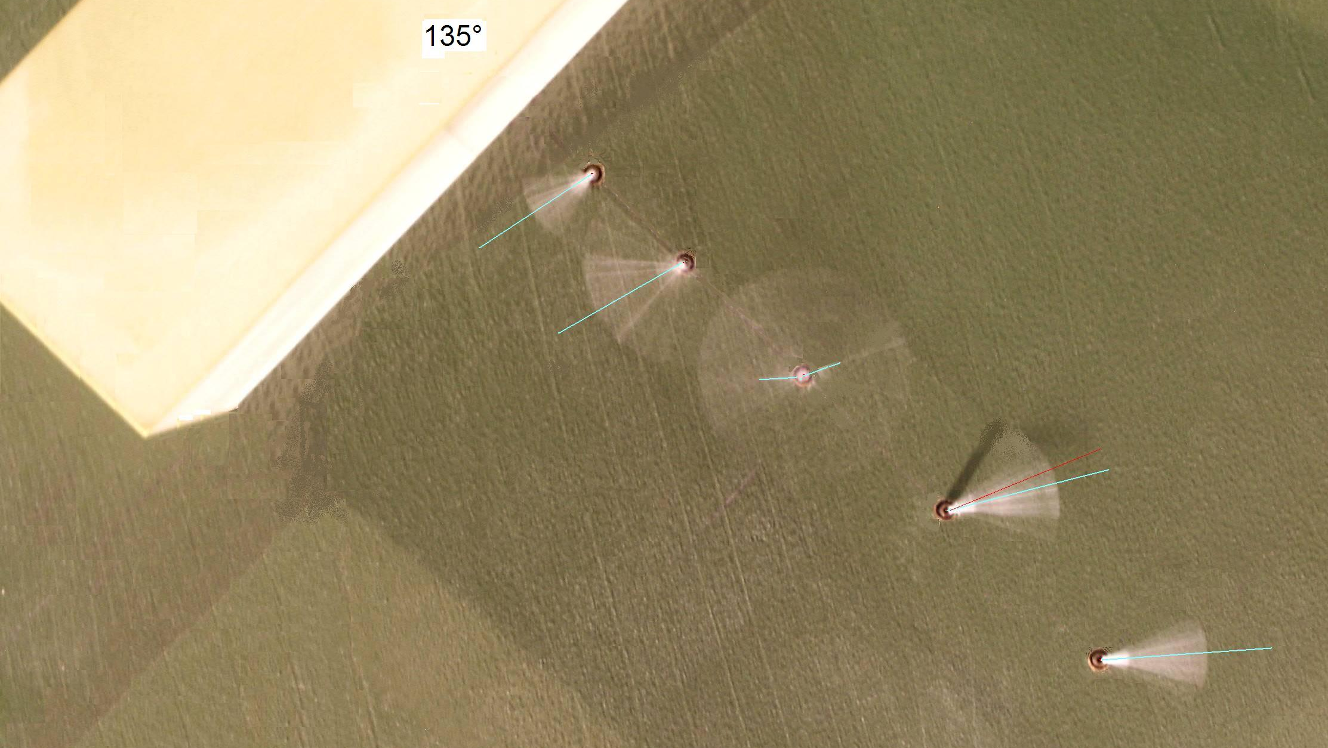

Fig. 7. Visualization of wind direction oscillations
Wind goes from left to right (as example)

Coefficients α, β and sector were processed from IRP and HWA signals for combination with this aim. The situations were excluded from further analysis where oscillation sector was greater than 2x 52° (that means, when the error on 55P13 Dantec probe was greater than 5%). Individual values of α and β coefficients processed from the 40 situations, using five different digital filtrations are plotted on Fig. 8 and Fig. 9.

2.3.2 Filtration and influence of cut off frequency

Fig. 8. Individual values of α coefficient - wind oscillation sector φ

IRP pressure signal is currently low pass filtered to exclude high frequency oscillations close the boundary layer bottom disturbing the local equilibrium state, causing validity of considered relation between instantaneous velocity and pressure distribution over the probe, see [1]. Secondary reason for low pass filtering follows from opinion that wind gusts substantially shorter than 2-3 s have no effect on human stability so they should be excluded from wind comfort analysis (standard deviations have impact on calculated effective wind gust velocity defined individually by a wind comfort criteria).

Fig. 9. Individual values of β - wind oscillation sector φ

Fig. 8 and 9 show plots of individual values of the coefficients (processed at several cut off frequencies) practically without any discernable correlation by wind oscillation sector.

As it is desirable to use unified α and β values for multiply processing, individually developed values in the test were averaged. Fig. 10 introduces the results, exhibiting a weak correlation of both coefficients and their standard deviation (scatter) with cut off frequency n.

Fig. 10. Averaged α , β coefficients with their standard deviations - cut off frequency

Considerably high scatter of α expressed by standard deviation (at that α acts as additive constant in velocity processing) draws attention on formulas for velocity evaluation, their check seems be useful. Course of both standard deviations sink moderately with diminishing cut off frequency for the low pass filtration. It is consistent with Irwin reasoning and with his reccomendation of n =25 Hz [1]. However, cut off frequency should consider also requirement of monitoring wind oscillations up to 0.3 or 0.5 Hz (in full scale), where wind effects on pedestrian balance act. Our 50 Hz, currently used as cut off frequency seems be a good compromise.

3. Pedestrian wind conditions in foot of high buildings (examples of IRP application)
3.1 Downwash effects near the windward facades of buildings. Wind action on pedestrians can be extremely adverse near the foot of plane and high windward façades during strong winds. Large vortices of ABL impact upper part of the buildings producing unsteady vertical streams (downwash). They rush towards ground evoking here strong horizontal gusts. Wind parameters on pedestrian level were tested in front of insulating building model that found 1 m behind end of roughness field proper to the suburb wind category. The model of rectangular building had again 58 mm (=a) and 175 mm (=b) base dimensions with the height of h=b or 2b (full scale prototype was base of 60 x 20 m and height of 60 m or 120 m). Mean wind velocity, standard deviation and peak distributions were obtained under axis of wide and narrow windward façades from measurement by five Irwin probes.

Fig. 11, 12 Mean wind velocity in front of windward wide and the narrow building facades

Fig. 13, 14. Peaks of wind velocity in front of the windward wide and the narrow facades

Fig. 11 and Fig. 12 demonstrate the mean velocity distribution on pedestrian level normalized by wind velocity pertained to height of z_{M}=30 mm (z=10 m in full scale) at model absence, Fig. 13 and Fig. 14 express likewise normalized velocity peaks. Evidently a region of reverse mean flow occurs close the building foot. Its extension is five times greater in front of the lower wide façade, or 7 times at the higher wide façade in comparison with narrow façade cases.
Absolute velocity peaks in front of the narrow facades reach maximally about 75% of peak values in front of the wide façades. But their distribution has quite other course for narrow variants, having minimum on position Δx/b ≈0,5 , instead of the local maximum observed for both wide facades in the position. Pedestrians are impinged here by horizontal gusts containing four times greater kinetic energy than it occurs in front of the narrow façades, irrespective their occurrence over broader area.

3.2. Wind conditions in a passage between two identical buildings.
The experiment had been inspired by [5], performed for pair of identical building models as described in sections 2.3.1 and 3.1. They were placed with the wide façades in a plane perpendicular to wind. Wind properties in pedestrian level were measured by 6 Irwin probes along axis of the passage between them. Mean velocity and standard deviation of velocity distribution along the axis are shown on Fig. 15 and Fig. 16 respectively for h=b=175 mm. The common coefficients of α= -0,281 and β=1,585 are used at the processing. Differences are obvious between IRP and HWA data (cut off frequency of HWA signal was only 300 Hz, for IRP signal 200 Hz at the early action in 2007. The experiment was repeated in 2008 then, with alternatives in building orientation and height, but the last data have not been processed yet).

Fig. 14 Mean wind velocity along the passage axis

Fig. 15. Standard deviation of velocity along the passage axis

4. Conclusion

Simple multidirectional probe and treating its pressure signal described by Irwin provide wind tunnel data acceptable for further evaluation on pedestrian wind comfort at connection with multiyear meteorological statistics for a site of interest. Accuracy of experiments moves in strong turbulent flow near buildings about 5 ÷10% (provided that all pressure records are processed using the averaged calibration coefficients). It is generally accepted as satisfactory, being comparable with meteorology data accuracy. Experiment showed that in special situations, as in positions on the border of recirculation zone, Irwin probe seems to give better exploitable data than direct use of HWA. With regard to this, some different measurement method should be parallel exploited with HWA (e.g. PIV) at α and β scatter analysis and some attention should be devoted also to structure of evaluating formulas.

Acknowledgment

The authors are indebted for promotion the work by GACR under project No.103/06/1522.

References

[1] Irwin H.P.A.H.: A simple omnidirectional sensor for wind-tunnel studies of pedestrian-level winds, Journal of Wind Engineering and Industrial Aerodynamics, Vol. 7 (1981), 219-239

[2] Wu H., Stathopoulos T.: Further experiments on Irwin's surface wind sensor , J. of Wind Eng. and Ind. Aerod., Vol. 53, (1994), 441-452

[3] ASCE Manuals & Reports on Eng. Practice, No.67 Wind Tunnel Studies of Buildings, American Society of Civil Engineers, Reston, Virginia 1999

[4] Durgin, F.H.: Pedestrian level wind studies at the Wright brothers facility J. of Wind Eng. and Ind. Aerod., 412-44, 2253-2264

[5] Blocken B., Carmelet J., Stathopoulos T.: A numerical study of the wind speed conditions in passages between buildings and the Venturi effect, 4 EACWE 2005, s. #112

[6] Jirsák M.: Větrné podmínky chodců v okolí rozměrných staveb (rešerše) VZLÚ R-3927/07
[7] Jirsák M. a kol.: Modelování větrných podmínek chodců s užitím Irwinových sond, VZLÚ
R-4361/08

[8] Jirsák M., Zachoval D.: Experimental study of pedestrian wind comfort over railway-station platforms, Engineering Mechanics Conference, Svratka (CR) 2008, 112-113

