

Institute of Philosophy of the Academy of Sciences of the Czech Republic, Prague
Centre for Medieval Studies
joint workplace of the Academy of Sciences and Charles University in Prague

FINANCIAL ASPECTS OF MEDIEVAL ECONOMY

International Conference

17 – 19 October 2013

Centre for Medieval Studies, Jilská 1, Prague 1

Conference programme

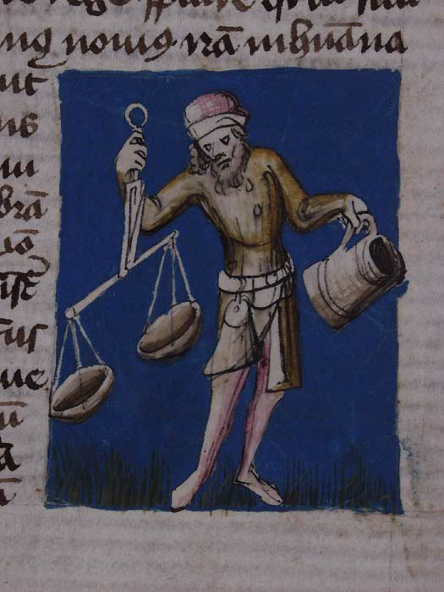

Thursday, 17 October

8:00 – 9:00
Registration

9:00 – 9:15
Welcome
Petr Sommer, director of the Centre for Medieval Studies, Prague

9:15 – 9:30
Opening lecture
Medieval finances in historiographical perspectives
Roman Zaoral (Charles University, Prague)

9:30 – 11:00
Session I
(chair: Andrew Wareham)

1. Currency depreciation and debasement in medieval Europe
Martin Allen (University of Cambridge)

2. New perspectives on the imperial coinage of the 14th century
Hendrik Mäkeler (Uppsala University Coin Cabinet)

3. Imperial monetary reforms in the Holy Roman Empire (15th and 16th centuries)
Michael North (University of Greifswald)

11:00 – 11:30 Coffee break

11:30 – 13:00
Session II
(chair: Martin Allen)

1. Reconstructing money flows in medieval Europe: the evidence of the Datini Libri di cambio (1388-1403)
Anthony Moore (University of Reading)

2. A neglected source of economic history: company records of the 1427 and 1433 Florentine tax censuses
Katalin Prajda (Institute for Advanced Studies, Budapest)

3. The long-distance trade commodities in medieval Bohemia
Linda Hroníková – Šárka Mašková-Janotová (Charles University, Prague)

13:00 – 14:00 Lunch

14:00 – 15:30
Session III
(chair: Michael North)

1. Markets, money-supply and urbanization in western England c. 800-1000
Andrew Wareham (University of Roehampton)

2. Remnants and traces. In search of the Breslau accounting books
(late 14th – early 16th centuries)
Grzegorz Myśliwski (University of Warsaw)

3. City rents in the financial contacts between Danzig and King Casimir IV
Beata Możejko (University of Gdańsk)

15:30 – 16:00 Coffee break

16:00 – 18:00
Session IV
(chair: Hendrik Mäkeler)

1. Bankiers des blinden Königs. Ein Beitrag zum Umgang mit Geld am Hof des ersten böhmischen Herrschers aus der Luxemburger Dynastie
Zdeněk Žalud (South Bohemian University, České Budějovice)

2. Financial dimension of the pledge policy of the King Sigismund of Luxembourg
Stanislav Bárta (Masaryk University, Brno)

3. King Sigismund deeds of pledge in Hungary
János Incze (Central European University, Budapest)

4. Die Finanzen und Finanzverwaltung des Herzogtums Österreich unter Albrecht V.
Petr Elbel (Austrian Academy of Sciences, Vienna / Masaryk University, Brno)

19:00 Dinner

Friday, 18 October

9:00 – 10:30
Session V
(chair: Petr Elbel)

1. Rechnungsbuch der Stadt Kremnitz aus den Jahren 1423-1424. Haushalt einer Berg- und Münzstadt im Königreich Ungarn in der Zeit von Sigismund von Luxemburg
Martin Štefánik (Slovak Academy of Sciences, Bratislava)

2. Böhmen im Licht der Nürnberger Stadtrechnungen der ersten Hälfte des 15. Jahrhunderts
Miloslav Polívka (Prague)

3. Old interpretations and new approaches:
the 1457-58 thirtieth customs register of Pressburg
Balázs Nagy (Central European University / Eötvös Loránd University, Budapest)

10:30 – 11:00 Coffee break

11:00 – 13:00
Session VI
(chair: Anthony Moore)

1. Financing a legation: papal legates and money in the later Middle Ages
Antonín Kalous (Palacký University, Olomouc)

2. St Vitus building accounts (1372-1378). The economic aspects of building the cathedral
Marek Suchý (Prague Castle Archives)

3. Rechnungsschriftstücke des Prager Domkapitels um die Wende
des 14. und 15. Jahrhunderts
Martina Maříková (Prague City Archives)

4. Economic aspects of the late medieval church fabric
Pavel Kůrka (Academy of Sciences of the Czech Republic, Prague)

13:00 – 14:00 Lunch

14:00 – 15:30
Session VII
(chair: Roman Zaoral)

1. Technique and operation of the accounting records in the town offices in Bohemia and Moravia before 1750 (methodology and application)
Pavla Slavíčková – Zdeněk Puchinger (Palacký University, Olomouc)

2. Beispielanalyse der Hofrechnungen des jagiellonischen Prinzen Sigismund
Petr Kozák (Provincial Archives / Silesian Provincial Museum, Opava)

3. Why not edit medieval account books digitally?
Georg Vogeler (University of Graz)

15:30 – 15:45
Closing discussion

16:00 – 18:00
Guided tour of the triphorium of St Vitus Cathedral (for foreign guests only)
Milena Bravermanová (Prague Castle Administration)

19:00 Dinner

Saturday, 19 October

Field trip to Kutná Hora
Departure at 7:59 from the main railway station
Coming back at 17:57

