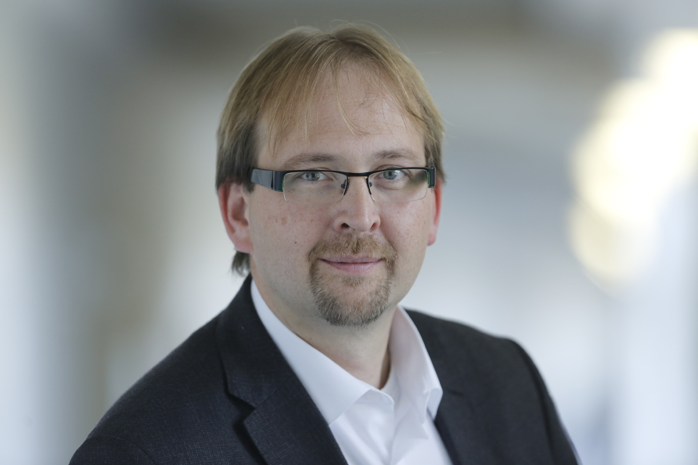

Scientific curriculum vita

Dr. Enrico Schleiff

Enrico Schleiff Scientific Career ...

... personal Data

Prof. Dr. Enrico Schleiff, born in Luckenwalde, 17.11.1971

... University Career

since 2012 Vice-President of the JWG University Frankfurt, Germany
since 2012 permanent W3 Position at the JWG University Frankfurt, Chair Professorship, Institute for “Molecular Cell Biology of Plants”,
2007-2012 temporary W3 Position at the JWG University Frankfurt, Head of the Institute for “Molecular Cell Biology of Plants”,
2003-2007 Independent Young Investigator group at the LMU Munich, founded by VW-Foundation
2003 Habilitation in Cell-Biology/Botany at the LMU München
1999-2003 CAU Kiel / LMU Munich, Germany; Mentor: J. Soll ”Structure determination of the Toc complex”
1999 Ph.D. Examination
1996-1999 McGill University Montreal, Canada; Mentor: G.C. Shore, Subject: “Characterisation of the mitochondrial outer membrane translocation receptor Tom20”
1994-1995 Diploma thesis (M.Sc. thesis), Biocenter of the University Basel, Switzerland; Mentor: Prof. Schwarz / Dr. Vergeres Subject: The influence of the myristoylation on function and structure of the MARCKS-related-protein (MRP)
1994 oral examination at GU Mainz, Germany
1993-1994 Laboratory work at the GU Mainz; Mentor: Prof. Otten, Subject: Experimental determination of the v (e+) mass in the tritium-ß-disintegration
1992-1995 Study of physics at the Gutenberg-University of Mainz
1992 First examination (B.Sc. degree), Charles University Prague, Czech Republic
1990-1992 Study of physics at the Charles-University of Prague, Czech Republic
1990 Laboratory work at the TU Dresden; Mentor: Dr. Märten, Subject: Theoretical description of the fragmentation yield of nuclear disintegration

... Fellowships / Awards / honors
2013 liaison officer of the Studienstiftung des deutschen Volkes
2004 Strassburger Preis, Germany
2004 Habilitationspreis of the LMU Munich, Germany
09/03-08/08 Volkswagen-Nachwuchsgruppenleiter (Deutschland)
01/99-08/01 HFSP Fellowship (Deutschland)
02/99 Entrance into the Book of honor McGill University
10/98 McGill Cancer Centre Award, Canada
05/98-12/98 McGill Major Ph.D. Award, Canada
10/97 Alma Mater Award, McGill University, Canada
03/97 McKinnell Award (Canada)
04/97-03/98 DAAD HSP-III Fellowship, Germany
04/96-03/97 DAAD HSP-II Fellowship, Germany
11/95 Award from the Nikolaus and Berta Burckhardt-Bürgerin foundation, Switzerland
08/95 Fellowship of the Dr. Carl Duisberg foundation, Germany
01-03/1995 Diplomarbeitsstipendium durch den Hilfsverein für Deutsche in Basel, Switzerland

... Positions
from 2014 Director of the Buchmann Institute of Molecular Life Sciences
since 2013 Director of the Security management board of the Goethe Unversity
since 2012 Co-Director of the Cluster of Excellence “Macromolecular Complexes”
since 2012 Chair of the SPOT-ITN funded by the Marie Curie EU-program
since 2012 Co-Director of UniWIND
since 2011 Vice chair of the SFB initiative 902
since 2009 Member of the Senate commission “Evaluation of “W”-Professorships”
since 2007 Principal Investigator of the Centre of Excellence Frankfurt
2011 Member of the Senate commission “Future concept of the university”
2010-2012 Prüfungsausschussvorsitzender of the Masterprogramm „Cell Biology and
Neurosciences“
2010-2011 Steering committee member for the SFB initiative 902
2009-2012 Prüfungsausschussmitglied „Bioinformatics“
2009-2012 Director of Center of Membrane Proteomics Frankfurt
2008-2012 Vice-Director of the Graduate College SFB 807
2008-2010 Mentor in the SciMento Program Hessen

... Activities
2012 Co-chair and organizer of the session: Plants Biochemistry and Molecular Biology at the First GBM and Polish Biochemical Society Meeting.
2011 Steering Committee member for the International Conference of the Botanical Society Germany in Berlin
2011 Steering Committee member for the GBM Conference in Frankfurt
2011 Organizer of the ESF funded summer school “Physiology and Biophysics of Photosynthetic Organisms”
2010 Organizer of the VW-foundation summer school “Membrane Proteomics”
2010 Organization of the international Conference on Evolution of Protein Transport Systems in Frankfurt
2009 Organization of the international Conference on Membrane Transport and Communication in Frankfurt (with Robert Tampe)
2008 Steering Committee member for the VAAM Conference in Frankfurt
2004 ELSO Meeting, Dresden, organization of the section “Protein Translocation”

... 1 selected manuscript for each major subject

HSP function: Hahn A, Bublak D, Schleiff E, Scharf KD. (2011) Plant Cell. 23: 741-755

Ribosome biogenesis: Missbach S, Weis BL, Martin R, Simm S, Bohnsack MT, Schleiff E. (2013) 40S Ribosome biogenesis co-factors are essential for gametophyte and embryo development. PLoS One. 8:e54084.

The TOC complex: Sommer MS, Daum B, Gross LE, Weis BL, Mirus O, Abram L, Maier UG, Kühlbrandt W, Schleiff E. (2011) Proc Natl Acad Sci U S A. 108: 13841-138416.

Cyanobacterial OM: Tripp J, Hahn A, Koenig P, Flinner N, Bublak D, Brouwer EM, Ertel F, Mirus O, Sinning I, Tews I, Schleiff E. (2012) Structure and conservation of the periplasmic targeting factor Tic22 from plants and cyanobacteria. J Biol Chem 287: 24164-24173.

Bioinformatic Analysis: Gessmann D, Flinner N, Pfannstiel J, Schlösinger A, Schleiff E, Nussberger S, Mirus O. (2011) Structural elements of the mitochondrial preprotein-conducting channel Tom40 dissolved by bioinformatics and mass spectrometry. Biochim Biophys Acta. 1807: 1647-1657.

