Remembering Tony Holý
Longtime Gilead collaborator passes away at age 75

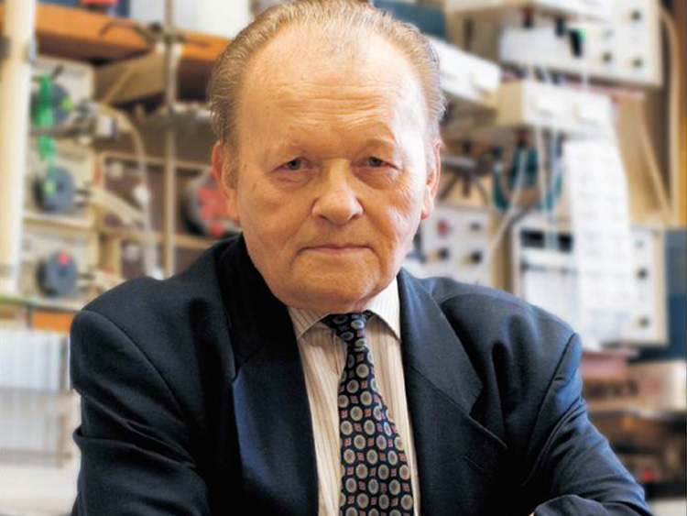
Professor Tony Holý in his synthetic chemistry laboratory at IOCB in Prague.

Dr. Antonín (Tony) Holý, a Gilead collaborator and past director of the Institute of Organic Chemistry and Biochemistry (IOCB) of the Czech Academy of Sciences in Prague, passed away on Monday, July 16, 2012. He was 75. He and virologist Dr. Erik De Clercq, of the Rega Institute in Leuven, Belgium, are the co-discoverers of the nucleotide family of compounds licensed to Gilead in 1991. The development and commercialization of Vistide, Viread, Hepsera, Truvada, Atripla and Complera are a result of their discoveries.

Many people at Gilead worked with Tony over the course of his long career. A remarkable man who was always in the lab, Tony spent time generating ideas and new compounds until the day before he retired from IOCB in 2010. It was only his declining health that prevented him from going on.

John Martin: “Tony and I were friends for 30 years and collaborated since 1986. Early on, because of our age difference, he was my mentor – as he has been for so many students in Prague over the decades. These students carry on his legacy in science. Tony’s interests were wide ranging. Probably less than one percent of our conversations involved nucleotide antivirals. We traveled the world together for conferences but always found time to explore the location. Everything fascinated him and was recorded by his camera. Chemistry was his first fascination and Tony knew how to identify and work on important projects.”

Bill Lee: “Tony had deep and diverse knowledge and interests. He keenly understood the politics of the new Europe; he was a visionary for scientific advancement in the Czech Republic; an able administrator; and a mentor and friend to so many. He will be missed.”

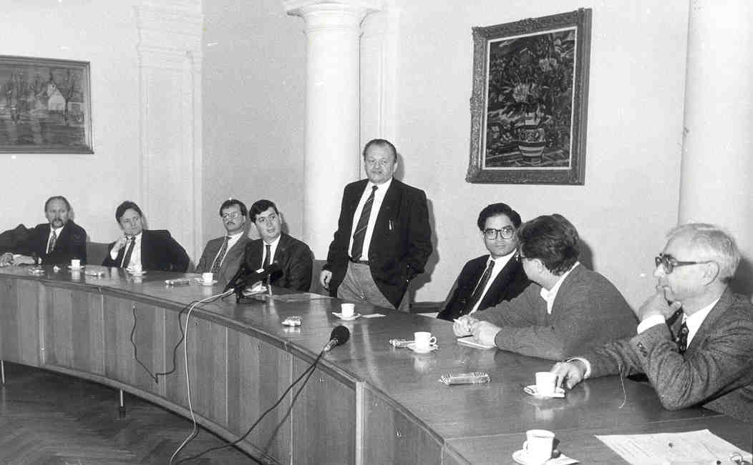
Early days of IOCB-Gilead collaboration: Professor Holý speaking at a press conference at the Czech Academy of Sciences about milestones and achievements of the IOCB-Gilead collaboration. Attendees from left: Mick Hitchcock, Bill Lee, Norbert Bischofberger and John Martin (all from Gilead), together with Professor Holý (standing), Michael Riordan (founder of Gilead), Ivan Votruba (Senior Scientist at IOCB) and Karel Martinek (Director of IOCB).

Tomas Cihlar: “What I admired most about Tony was his focus on making science useful. He ignored trendy research that would buy him a moment of fame, but every day he was deeply dedicated to making meaningful discoveries that would improve people’s lives. The methyl group that Tony added to adefovir to make tenofovir is a pure demonstration of his genius: very simple chemical modification, yet so profoundly effective for therapy. Tony remained a very modest man despite all his achievements and a role model for many younger scientists.”

Mick Hitchcock: "One of Tony's great strengths was his openness to collaboration. While some academics can be secretive, he was not. He saw the value in working with and through other people. I last saw him in May 2011 when several of us traveled to Prague to celebrate his work in acyclic nucleoside phosphonates. While constrained by his physical limitations, he clearly enjoyed the event, smiling often and taking many pictures. I will also remember always his guided tours of Prague, which I was privileged to experience."

Norbert Bischofberger: "I met Tony for the first time in Prague in 1991. What impressed me about him was that he enjoyed being in the lab every day. At the same time he also understood the potential applications of his inventions which he was very motivated to explore. That led to a collaboration of his lab with Erik De Clercq’s and to a close collaboration with Gilead resulting in a number of products. Three million patients world wide are taking medications containing molecules which were first synthesized in his lab. Tony was both an excellent scientist and a visionary. I am thankful for having had the opportunity to work with him and his team at the IOCB."

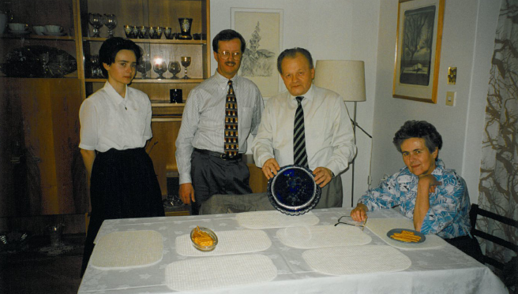
Professor Holý with his family and Norbert Bischofberger in Prague in 1997. Professor Holý holds a crystal plate, a gift designed by Norbert, with an engraving of tenofovir structure.

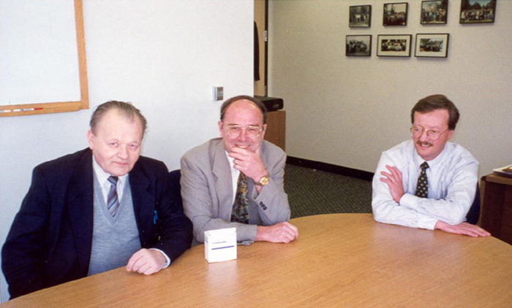
Professor Holý (left) with Professor De Clercq (middle) and Norbert Bischofberger (right) in April 1998, with a package of Preveon (developed for HIV). We should have known from Tony’s skeptical expression that Preveon was not to be successful.

BIOGRAPHY. Professor Antonín Holý was born on September 1, 1936 in Prague (former Czechoslovakia). He graduated in organic chemistry from the Charles University in Prague in 1959, and earned a Ph.D. in 1963 at the Institute of Organic Chemistry and Biochemistry of the Czechoslovak Academy of Sciences. He remained at the Institute for the rest of his career rising from staff scientist in the group of nucleic acid chemistry to head of the group in 1983 and later head of the Department of Bioorganic Chemistry in 1987. From 1994 to 2003 he served as Director of the Institute.

During his career he published more than 600 scientific papers and many book chapters, and focused on the practical aspects and applications of his research, filing more than 60 patents and patent applications.

Professor Holý received multiple awards and prizes for his scientific achievements. In 2001, he and Professor De Clercq received prestigious Descartes Prize of European Union for the discovery of antiviral nucleoside phosphonates. In 2006, he became a member of the European Academy of Sciences and Arts. In addition, he received honorary doctorates and professorships from multiple Czech and European Universities including the Ghent University in Belgium and the Manchester University in United Kingdom.

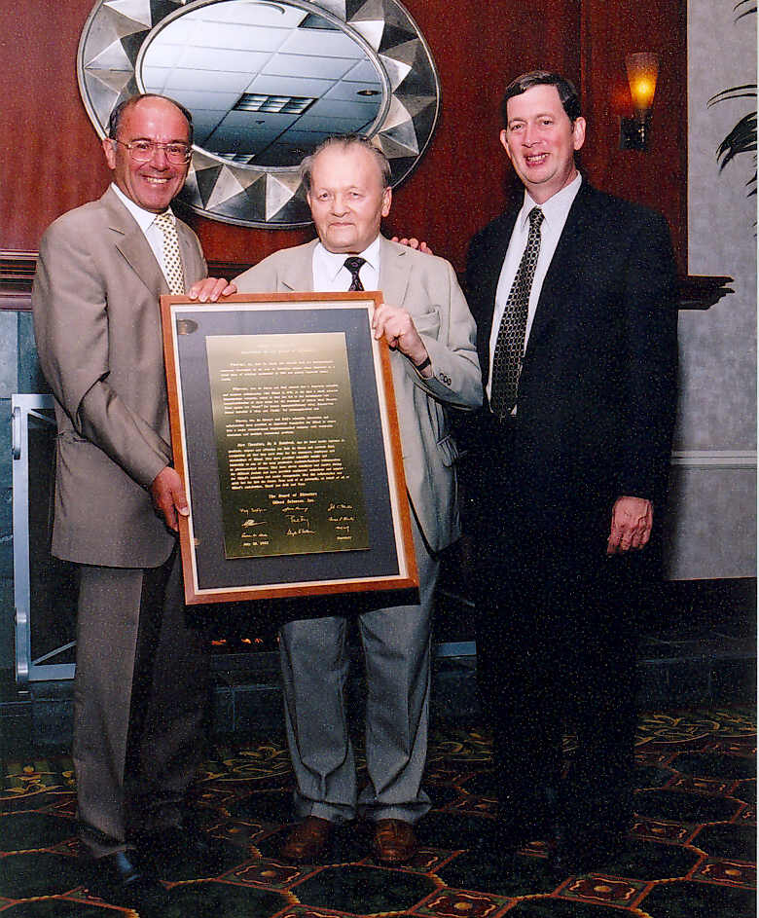

Professor Holý (middle) with Professor De Clercq (left) and John Martin (right) in California at a Gilead Board dinner in July 2003. Gilead’s copy of the plaque recognizing Tony and Erik and signed by Board members is displayed on the second floor of Building 333 in Foster City.

In a special edition of the Collection of Czechoslovak Chemical Communications (this one published on the occasion of Tony's 70th birthday), Editor-in-Chief Michal Hocek wrote:
"For quite a long time at the beginning of his independent career Professor Holý was forbidden to supervise students due to political reasons and worked alone with the help of just one technician. Only from the 80’s he was allowed to slowly build a small group, and from the 90’s he has been able to supervise multiple Ph.D. and MS students and build up his group to its current size of approximately six staff scientists and 12 students. In the 90’s he also began to give lecture courses at Czech universities and was promoted to full professor in 2005 at the Palacký University in Olomouc.

"Throughout his career, Professor Holý has been a perfect example of true multi- and interdisciplinary research. He profited from his excellent organic synthesis background, but his strong affinity to biochemistry, biology, and medicine has resulted in a number of applications and fruitful collaborations. He has always been very keen on studying the mechanisms of action of his compounds, and such knowledge has helped him in the design and synthesis of further generations of active compounds. He has never trusted computational design or combinatorial approach too much; he relied on his extensive multidisciplinary knowledge and on his 'nose for biological activity that proved to be more successful than any fancy modern approaches. Most of all, however, he relied on very hard work. Even at the beginning of his career without coworkers and despite little (if any) support from the superiors, he was able to produce an enormous amount of excellent work.

"He has become a leading figure in medicinal chemistry of nucleic acid components, and his work has significantly influenced the research both in academia and in pharmaceutical industry. He personally has never cared too much about the citation impact of his work (though over 9500 citations of his works since 1980 can be found on Web of Science) or about receiving prizes but he is truly pleased and satisfied by clinical applications of his compounds that help to cure patients suffering life-threatening diseases."

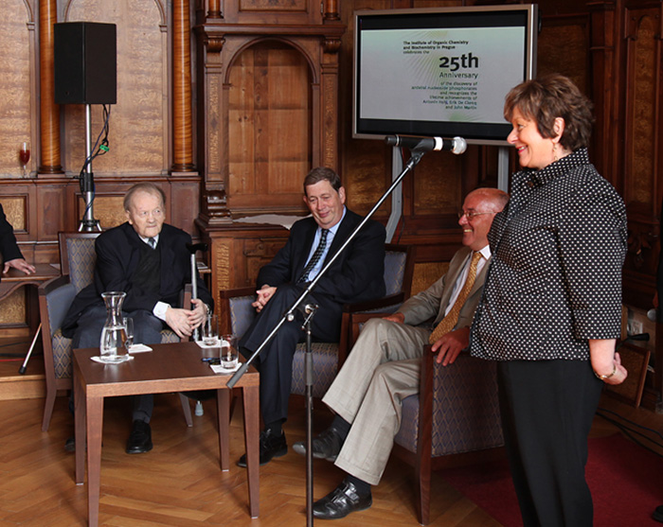
Professor Holý (left) with John Martin (middle), Professor Erik De Clercq (right), and Her Excellency Renilde Loeckx (standing), a Belgian Ambassador in Czech Republic, during the celebration of the 25th anniversary of the discovery of antiviral nucleoside phosphonates in May 2011 in Prague. This was the last time a Gilead group met with Professor Holý.

