Ústav experimentální botaniky AV ČR, v. v. i
Budova B1 čítárna v přízemí, Rozvojová 263, Praha 6 Lysolaje

Středa 4.12. 2013 v 10.00

Seminář

Prof. Peter Doerner

Institute of Molecular Plant Sciences , School of Biological Sciences, University of Edinburgh, UK

Control of root growth by phosphate limitation

Phosphate is poorly mobile in soils, thus roots have to come into close contact with Pi-rich domains for assimilation. Root system architecture (RSA) therefore has a profound effect on Pi acquisition efficiency by optimising foraging capacity. Currently unknown genetic controls underpin RSA ideotypes particularly efficient at Pi acquisition, e.g. with prolific shallow lateral roots with low growth angles. However, root systems adapt to growth in low-Pi soils by enhanced lateral root growth and branching and suppression of primary root growth. Our lab is interested in identifying the mechanism underpinning these adaptive responses.
The lab has recently identified novel genetic components of a pathway that controls cell division and stem cell maintenance in low phosphate. These results highlight the importance of secretory pathways in coupling homeostasis of mineral nutrients to growth behavior. We will present results of our recent analysis of phosphate-responsive growth control networks.
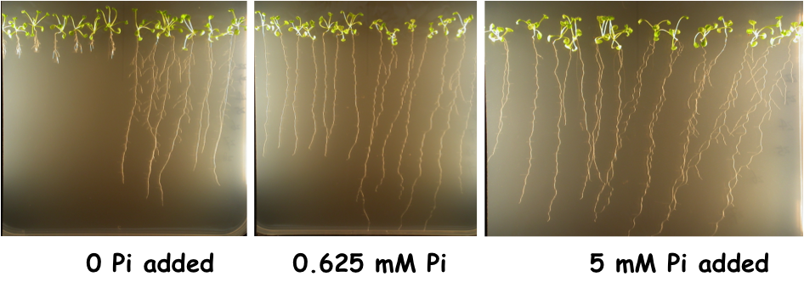

Všichni hosté jsou vítáni!

