Institute of Geonics of the CAS
Department of Environmental Geography

organises
International workshop on the topic

Current environmental threats and their impact
in the landscape

Brno 25. – 26. October 2016
Institute of Analytical Chemistry of the CAS, Veveří 967/97, Brno, Czech Republic

The workshop is organised with the support of Czech Academy of Sciences as an element of Strategy AV21, Research Programme "Natural Threat"

Invitation

Dear colleagues,
We would like to invite you to an international workshop "Current environmental threats and their impact on the landscape", which is organised with the support of the Czech Academy of Sciences as an element of research Programme Strategy AV21 "Natural threats ". The workshop will focus on presenting the results of research of environmental, mainly natural threats and their impact on the landscape and society.

Papers are promised by:
Prof. RNDr. J. Minár, CSc. (Faculty of Science, Comenius University in Bratislava)
Prof. RNDr. R. Brázdil, DrSc. (Faculty of Science, Masaryk University in Brno)
Prof. RNDr. T. Pánek, Ph.D. (Faculty of Science, University of Ostrava)
RNDr. Oldřich Krejčí, Ph.D. (Czech Geological Survey, Branch Brno)
RNDr. J. Stemberk, Ph.D. (The Institute of Rock Structure and Mechanics of the CAS)
Assoc. Prof. RNDr. J. Kolejka, Ph.D. (Institute of Geonics of the CAS, Dept. of Environmental Geography, Brno)
Mgr. P. Klusáček, Ph.D. (Institute of Geonics of the CAS, Dept. of Environmental Geography, Brno)

Depending of interest of participants, a field trip within the Brno and its surroundings focusing on issues of urban landscape and its current transformation will be organised in the second day of meetings in the afternoon. Participation in the workshop is for free. Collection of extended abstracts will be published with ISBN.

Workshop topics:
- Natural threats (slope deformations, floods, drought), their impacts on the landscape and the possibility of their evaluation,
- Social and economic consequences of natural and man-made disasters

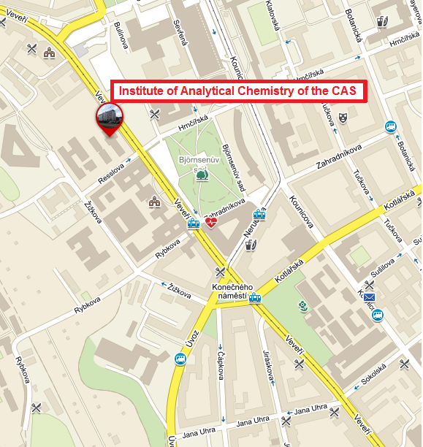
Organisational instructions
Participation is for free

Venue
Institute of Analytical Chemistry of the CAS, Veveří 967/97, Brno, Czech Republic

Official languages of the conference are Czech, Slovak, English

Oral presentation
The time for oral presentations will be limited to 15 minutes. Technical equipment (laptop/notebook, projector) will be provided. In the case of a large number of papers, the organizers reserve the right of selection of the presented papers; the other will be presented as posters. Abstracts of posters will be included in the Proceedings of the Workshop as well.

Proceedings of the workshop
Collection of extended abstracts will be published with ISBN.

Abstracts
The length of the abstract should be between 500 (minimum) and 1000 (maximum) words, including text and references. The text should be supplied by electronic mail in the Microsoft Word processor (single spacing, font size 12 Times New Roman, justified). The authors are responsible for the content and linguistic accuracy. It is possible to register a paper and a poster to the poster session, too.

Field trip
The second day of workshop (26.10.2016) a coach field trip to the Brno and its surroundings will be organised. A topic of field trip will be focused on issues of urban landscapes and their current changes, especially on the issue of brownfields.

Deadlines
We ask you to send kindly your registration and themes of papers or posters by July 31, 2016 at the latest. (It is possible to register a paper and poster to the poster session too.)
The second circular is to be distributed to registered participants during the first half of August 2016.

Preliminary programme:
Tuesday, October 25, 216
8.00 - 9.00 Registration of participants
9.00 to 9.15 Opening, introductory word
9.15 to 11.30 - Morning block of lectures
11.30 - 13.00 - Lunch
13.00 to 15.00 - Afternoon block of lectures
15.00 to 15.30 - Coffee break
15.30 to 17.30 - A continuation of lectures, poster presentations
Wednesday, October 26, 2016
8.30 to 11.15 - Morning block of lectures
11.15 to 11.30 - The end of the workshop
11.30 - 13.00 Lunch
13.00 to 16.30 A field trip to Brno and its surroundings, focusing on issues of urban landscapes and their current changes, particularly on issues brownfields (according to the number of registered participants).

Assoc. Prof. RNDr. Karel Kirchner, Ph.D.
in the name of Organizing Committee

Contact address:
Institute of Geonics of the CAS
Dept. of Environmental Geography
Drobného 28, 602 00 Brno, Czech Republic
e-mail: aeh@geonika.cz

REGISTRATION FORM
INTERNATIONAL WORKSHOP "CURRENT ENVIRONMENTAL THREATS AND THEIR IMPACT IN THE LANDSCAPE"

Name: _____________________________ Title:___________________________
Surname:___________________________________________________________
Institution: _________________________________________________________
Address:____________________________________________________________
Country: ___________________
E-mail: ____________________________________________________________
Phone: _____________________ Fax: __________________________________

Participation with: □ paper □ poster
Title of presentation/poster
(In the case of a large number of papers the organizing committee reserves the right of selection of the presented papers. Abstracts of all offered papers and presented posters will be published in the Proceedings of the workshop)






Participation in the excursion □ Yes □ No

Date: ______________________ Signature: _______________________________

Please, send the Registration to the address: aeh@geonika.cz

