numerical simulation of a wing body interaction

David Šimurda, Lukáš Popelka
Institute of Thermomechanics, Academy of Sciences of the Czech Republic, Prague
Lubor Zelený
Aeroclub Přibyslav, Přibyslav
Milan Matějka
Faculty of Mechanical Engineering, Czech Technical University in Prague, Prague

Abstract
In order to investigate and understand extent of the wing-body interaction effects taking place during operation of a particular self-launching sailplane, commercial code Fluent 6.3 was used for numerical simulation of flow past a simplified model of TST-10a. Several methods were used to identify vortex structures originating due to interference effects in this part of the aircraft. 3D effects and distortions of pressure and velocity distributions taking place in the junction of the body and the fuselage were observed.

1 Wing Body Interaction Effects
Much attention has been already paid to flow phenomena occurring in region of a wing-fuselage junction. According to Schlichting & Tuckenbrodt (1979) or Boermans & Terleth (1983) main aerodynamic effects of wing-fuselage interference consist of:
i) Displacement effects taking place due to spanwise curvature of the intersection lines between the wing and fuselage. As a result streamwise velocity distribution on the wing changes towards the fuselage.
ii) Effects of asymmetry i.e. difference between the wing-fuselage intersection lines of upper and lower surface. Intersection lines differ when the wing is shifted to a high wing or low-wing position, when the wing is cambered or set at incidence angle relative to fuselage. Supposing the fuselage is of cylinder-like shape. This leads to change of velocities on both sides of the wing according to particular geometrical setup.
iii) Lift effects originates from interaction of circulatory flows around the wing and the fuselage. Upwash in front of the wing and downwash behind the wing are influenced by additional fuselage crossflow velocity (alpha flow) at the junction. If both a cylindrical fuselage and the wing in mid-wing position are at positive angle of attack, then due to alpha flow the angle of attack at the wing root is higher.
iv) Effects of viscosity result in flow separation and generation of vortices. Due to strong adverse pressure gradient in front of the wing root leading edge the boundary layer on the fuselage separates from the surface along a separation line thus forming a horseshoe vortex. Both upper and bottom branch of this vortex spread streamwise along the wing root. Due to induced angle of attack and usually divergent shape of the junction, the location of the boundary layer transition on the wing shifts upstream as we draw closer to the junction forming a turbulent wedge. This leads to flow separation at higher angles of attack.

3 Tested sailplane
Measurements were performed on a particular self-launching TST-10a sailplane designation OK-A631 /LZ/ (Fig. 1). It is a one seat composite ultralight glider with fixed undercarriage and retractable propulsion unit. Main dimensions of the TST-10a wing are presented in Figure 2.

4 Computational model
Geometry of the model was simplified in comparison to the real aircraft (Fig. 3). It is clear from the figure that empennage was omitted and only the inner part of the wing was considered. Coordinates of the fuselage were taken from Boermans & Terleth (1983) model No.1. The wing was considered rectangular. Insignificant fillet in the junction of the wing and the fuselage was also neglected.
The whole computational domain with applied types of boundary conditions can be seen in Figure 4.
In order to ensure accurate results and to keep computational costs as low as possible, hexahedral grid was used for meshing of the computational domain (Fig. 5). Mesh was refined at walls. Due to problems with geometry, however, laminar sublayer was not resolved everywhere in the domain. Maximal value of y⁺ was 17.
Flow properties at the inlet are characterized by inlet velocity v = 23.6m/s (85km/h) and inlet turbulence intensity Tu = 0.2%. Straight flight is modelled hence angle of attack of the wing is α = 4°. Outlet to atmospheric pressure at turbulence intensity Tu = 0.2% is considered at the exit from the domain. The second order accuracy scheme is used for discretization of governing equations. Turbulent flow is modelled using realizable k-ε model of turbulence, which performs well in flows involving rotation, boundary layers under strong adverse pressure gradients, separation, and recirculation. Near wall flow is modelled using combination of a two-layer model and wall functions.

5 Methods of vortex identification
Since some of the effects taking place in the fuselage wing junction results in generation of vortex structures, we need to be able to identify these structures in the flowfield. There exist numerous methods of vortex identification. Those methods used in this research are described below.

- Mapping of streamlines onto a plane normal to the vortex core
Structure is called vortex when instantaneous streamlines mapped onto a plane, normal to the vortex core, exhibit roughly spiral or circular pattern, when viewed from a reference frame moving with the centre of the vortex core Robinson (1991).

- Q-criterion
Vortex exists in locations where rotation dominates over strain. The second invariant of velocity gradient Q is positive in such locations.

$Q=\frac{1}{2}\left(Ω_{\text{ij}}Ω_{\text{ij}}−S_{\text{ij}}S_{\text{ij}}\right)$ (1)

$Q≥Q_{\text{th}}$ (2)

- Normalized helicity
Angle between velocity vector and vector of vorticity is zero in vortex core. Normalized helicity is defined as a cosine of this angle.

$H_{n}=\frac{w_{i}⋅ω_{i}}{\left|w_{i}\right|⋅\left|ω_{i}\right|}$ (3)

Hence the vortex core is defined as

$\left|H_{n}\right|=1$. (4)

6 Results of numerical modelling
Distribution of static pressure on the wing and the fuselage (Fig. 6) shows increase of static pressure on the wing upper surface as we draw closer to the fuselage. This is consequence of displacement effect mentioned previously in the second paragraph. Distributions of pressure coefficient cp along wing sections at various distances from the fuselage were evaluated and are shown in Figure 7. Distribution curves of sections at locations closer to the fuselage are incomplete as a result of the junction geometry. This is also reason for the displacement effect. Decrease of values of cp closer to the junction is evident.
We can also notice shift of the stagnation point location in chordwise direction in case of section located at z = 0.248m (the first section whose incomplete cp distribution curve contains stagnation point – the blue curve in the detail in Figure 7). This stagnation point shift quantitatively describes effects of “alpha flow”, whose consequence is increase of angle of attack of the wing in close proximity of the fuselage. The difference between the angle of attack of flow undisturbed by the fuselage and the flow in close proximity of the fuselage (z=0.248) is 30°. Whole situation is well visualized by distribution of static pressure in figure 8.
Generation of the horseshoe vortex can be seen in Figure 9. Streamlines in the picture are mapped onto a plane perpendicular to the wing surface in region of stagnation point. It can be clearly seen how the boundary layer on the fuselage surface separates and forms the vortex as described in the second paragraph. We can also observe another much smaller contrarotating vortex closer to the leading edge. Contours of the total (over)pressure indicate that the boundary layer thickness prior to the vortex generation was approximately 30mm. Value of the boundary layer thickness is high, since the whole flow was considered to be turbulent.
Further development of the horseshoe vortex is illustrated in Figure 10, which shows contours of q in planes perpendicular to longitudinal axis of the model. Planes are located in longitudinal positions 0.01, 0.49, 0.71, 1.14, 1.57, 2.22, 3.08, 3.94 of x/c with respect to the leading edge. We can see that both branches upper and bottom more or less follow upper and bottom surface of the wing and stretch further downstream. Detail of the two vortex branches can be seen in Figure 11.
Flow separation was not predicted by the simulation, although the steep pressure gradient on the upper surface behind x/c = 0.4 (Fig. 7) would suggest so. In-flight tests really prove flow separation on the upper surface of the wing close to the fuselage. Reason why the numerical simulation failed to predict flow separation is probably inadequately refined mesh on the surface of the wing. Cells with the highest value of y⁺ as mentioned before in paragraph 4 were located just on the upper surface of the wing.

7 Conclusions
Numerical calculations helped to investigate flow structures in the wing-fuselage junction to some extent only. Calculated flowfield in the junction region embodied displacement and lift effects and viscous effects represented by the horseshoe vortex. Separation visualized during in-flight testing, however was not observed, although geometry simplifications of the computational model (no fillets, no fairing) were “separation friendly”. To correct this shortcoming mesh needs to be refined in near wall region at least and turbulence model with transition should be applied. Also validating wind tunnel measurements will be performed.

8 Acknowledgement
The work has been supported by grant projects GA AS CR No. IAA2076403 and No. IAA200760614, by Ministry of Education, Youth and Sports of the Czech Republic - project No. 1M06031 and by the Czech Science Foundation - project No. 101/07/1508

References
Schlichting, H., Truckenbrodt, E. (1979): “Aerodynamics of the Airplane”, McGraw-Hill, New York
Boermans L.M.M., Terleth D.C. (1983): “Wind Tunnel Tests of Eight Sailplane Wing-Fuselage Combinations”. 18th OSTIV Congress, Hobbs, New Mexico
Robinson, S. K. (1991): “Coherent Motions in the Turbulent Boundary Layer”., Ann. Rev. Fluid. Mech. Vol. 23.
Popelka, L. (2006): “Aerodynamic Optimization of Sailplane Airfoils”. Doctoral thesis, CTU, Prague, Czech Republic.

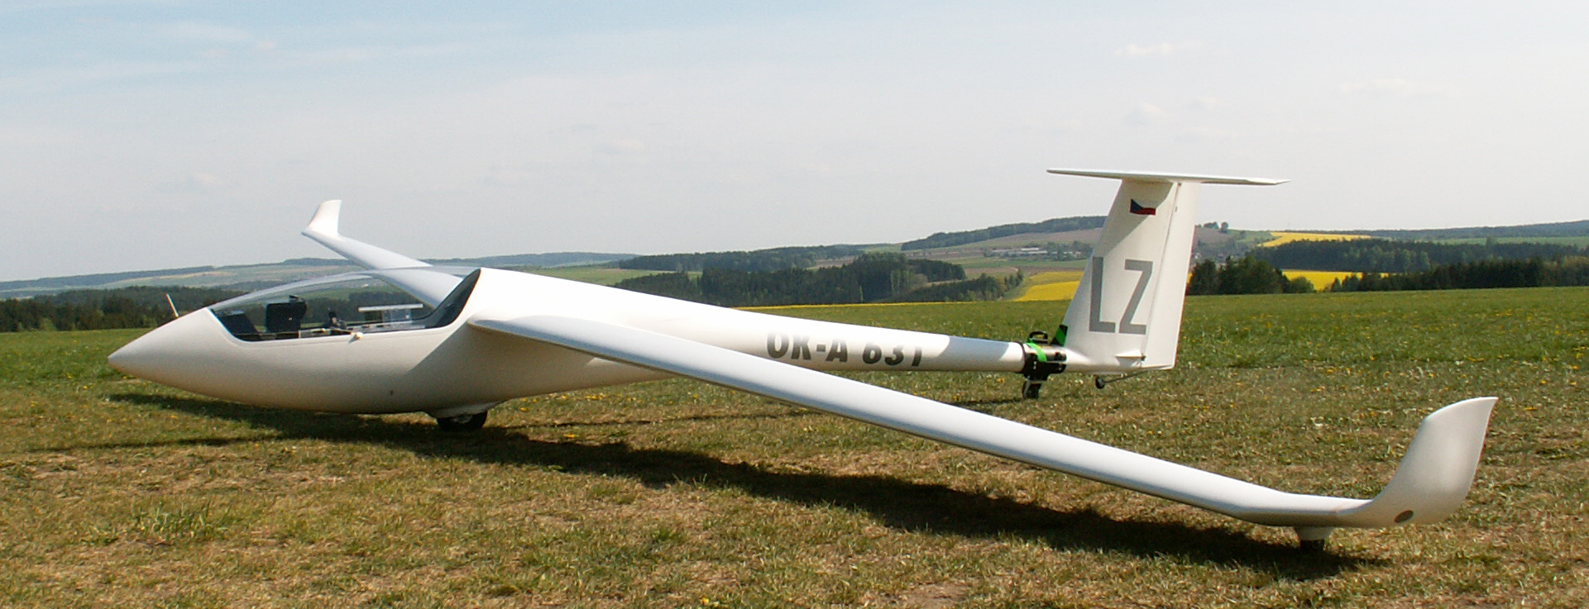

Fig.1 Test aircraft TST10a OK-A631 /LZ/.

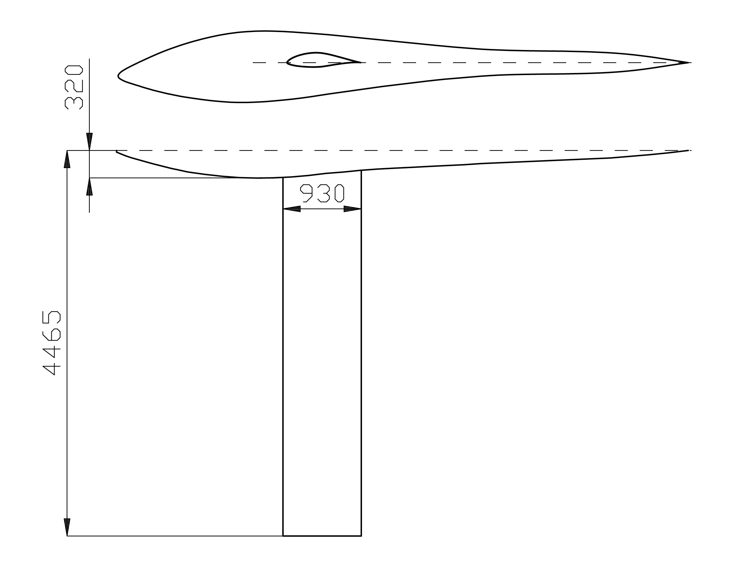

Fig.3 Sketch and dimensions of the geometrical model used for CFD calculations.
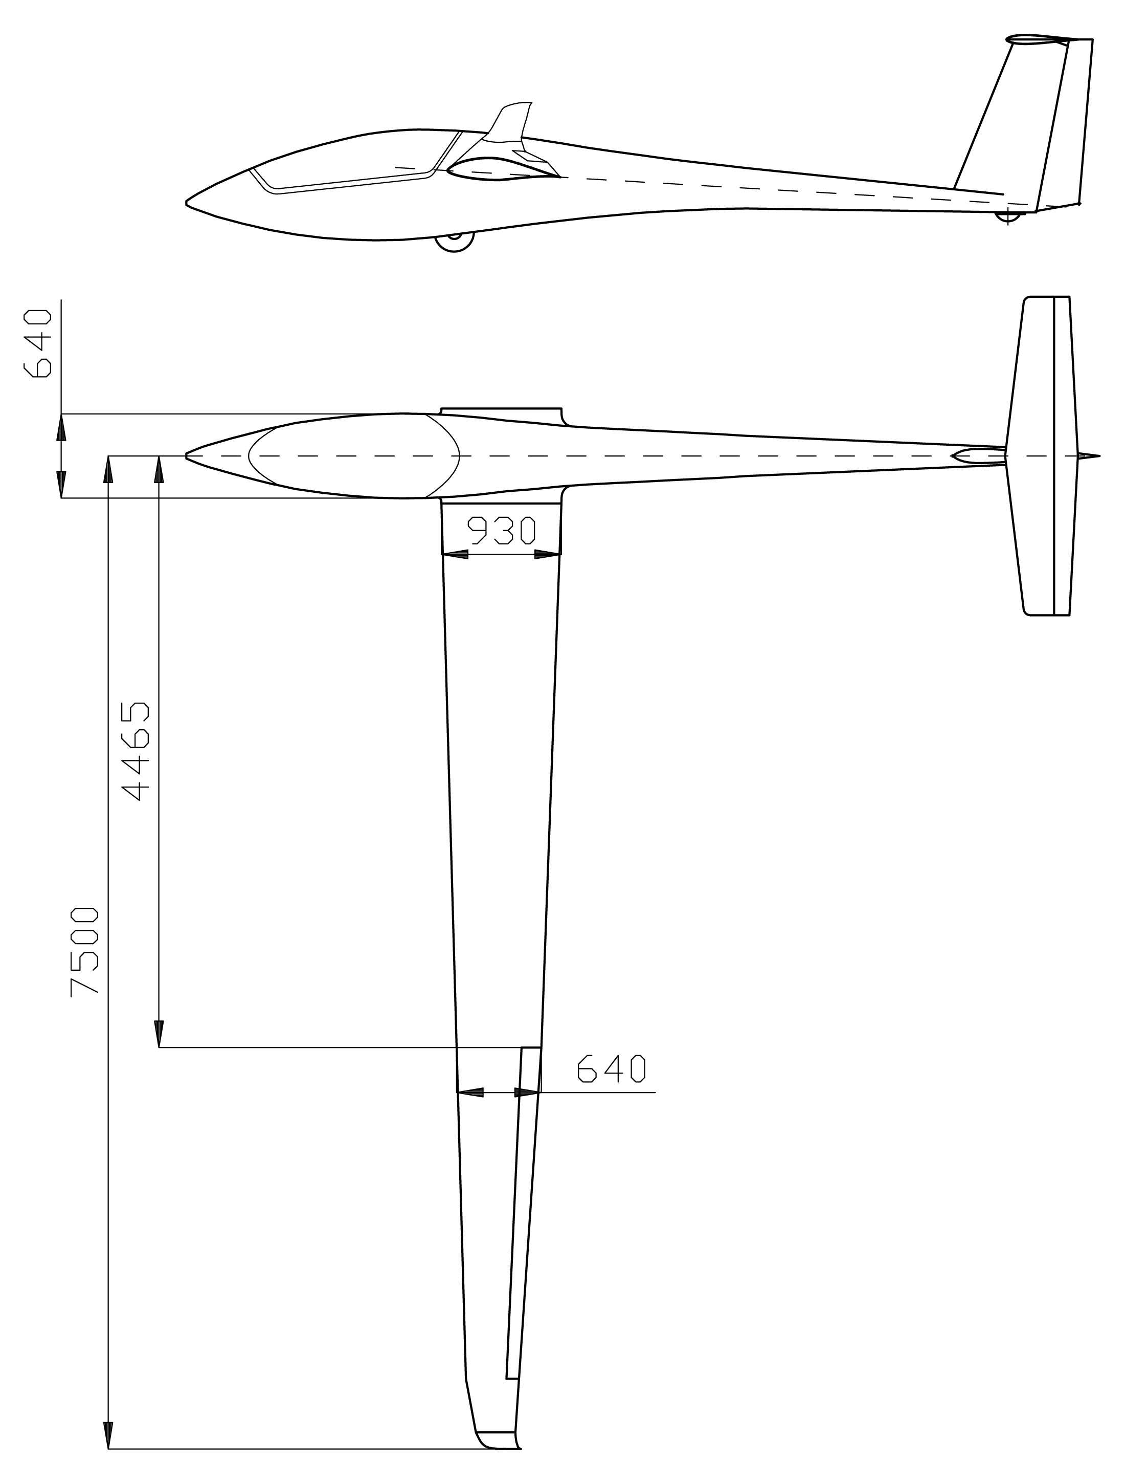

Fig.2 Test aircraft TST10a OK-A631 /LZ/ - main dimensions.
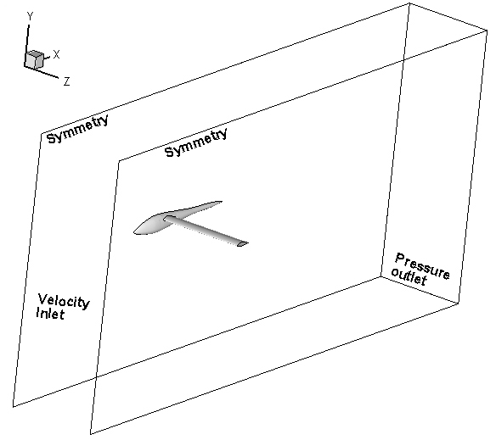

Fig.4 Scheme of the computational domain with boundary condition types.
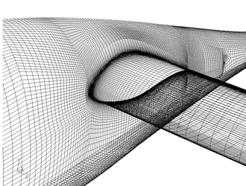

Fig.5 Mesh of the computational domain.
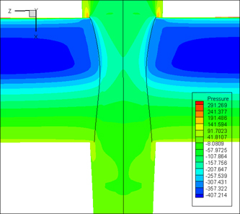

Fig.6 Static (over)pressure distribution on the fuselage and the wing.

Fig.7 Distributions of cp along wing sections located at different distances from the fuselage (z coordinate). Location of vortex generator (VG) used in in-flight tests.
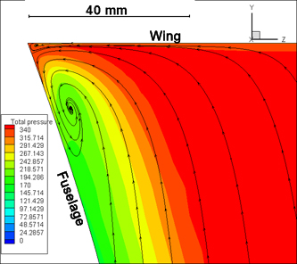

Fig.9 Streamlines mapped onto a plane perpendicular to the wing surface with contours of total (over)pressure.

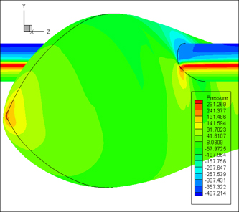

Fig.8 Static (over)pressure distribution on the fuselage and the wing.

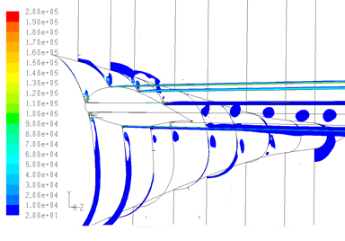

Fig.10 Contours of Q in planes perpendicular to longitudinal axis of the model showing development of the horseshoe vortex.
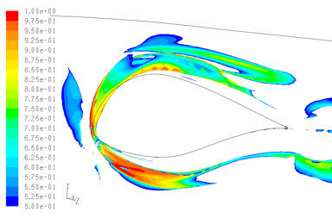

Fig.11 Isosurface of Q = 10 covered with contours of absolute helicity ranging from 0.5 to 1.

