Geoarchaeological research in Kaptar Kamar Rockshelter
Preliminary fieldwork report
September 1. – 18. 2017

Ladislav Nejman, Lenka Lisá, Miriam Nývltová Fišáková, Michaela Ryzá, Vít Záhorák, Shapulat Shaydullaev, Ladislav Stančo

University of Sydney, Australia
Institute of Geology CAS, Prague, Czech Republic,
Institute of Archaeology CAS in Brno, Czech Republic
Masaryk University, Brno, Czech Republic
Palacky University, Olomouc, Czech Republic
Termez University, Uzbekistan
Charles University, Prague, Czech Republic

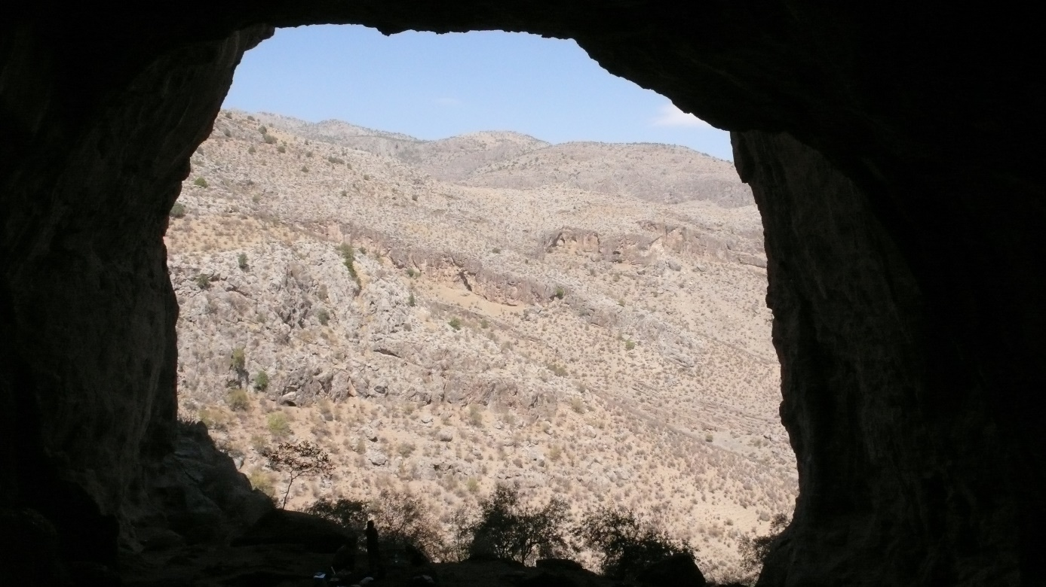

Introduction

The objective of the 2017 summer season of the Czech geoarchaeological survey (environmental geology project) was to begin a geoarchaeological prospection of Kaptar Kamar Cave. The two main tasks for the 2017 summer season included:
- archaeological excavations of Kaptar Kamar Cave (investigation of human activities from the Palaeolithic up to recent times)
- geoarchaeological and paleozoological research (investigation of climatic changes in the sedimentary environmental archive)

The expedition planned to spend twenty days in the field. No work was done in the first two days (30 – 31st August) as the expedition members were requested by local officials to delay the commencement of work to obtain necessary permits. The first day in the field (1st September) was dedicated to detailed mapping of the cave floor. On the second day (2nd September) archaeological excavations began. People present at the site included director of excavations Ladislav Nejman and co-workers Michaela Ryzá, Vít Záhorák and Hayitmurod Xurramov. One week later two more researchers (sedimentologist and geoarchaeologist, Lenka Lisá and zooarchaeologist Miriam Nývltová Fišáková) arrived. The final days of the excavations (17 – 18th September) were dedicated to sampling, documentation and backfilling of the excavated pits.

This report presents the findings and preliminary results of the first (summer, 2017) season of the Czech geoarchaeological survey in Kaptar Kamar Cave. The findings and results were divided into three parts, according to the scientific tasks planned for this season.

Archaeological excavations of Kaptar Kamar Cave
The site was divided into a grid, which was later used to select excavation squares. In total 12 squares (1x1 meter; labelled A to M) were chosen for excavation. The squares were then systematically excavated by mechanical layers (Excavation Unit – XU), roughly 10 cm thick. In some cases the spatial relationships of some layers were complex and more than one sedimentary unit was included in a single XU. The stratigraphic relationships between the units were recorded after the square was fully excavated. Two samples of sediment from each XU were collected for phytolith analysis and floatation for macroscopical remains.

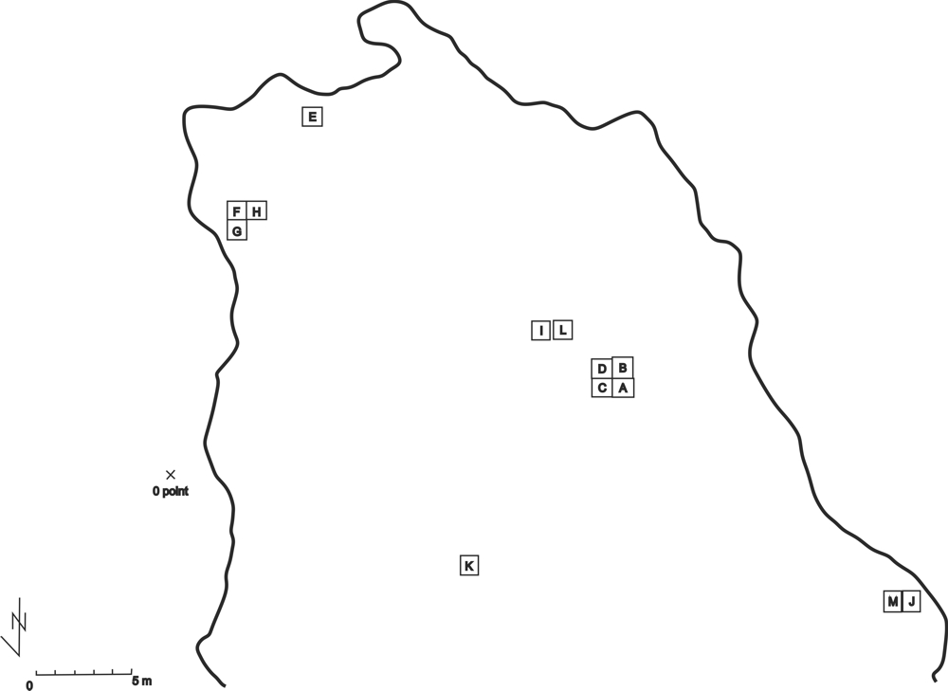

Fig. 1 – Plan of Kaptar Kamar Cave with positions of squares selected for excavation

In addition, all excavated sediment were dry sieved at the site using 3 mm sieves. Therefore, a vast collection of charcoal samples and faunal remains was collected during the excavation. Several lithic artefacts were also found. Some of the most prominent artefacts and charcoal samples that were identified during excavations were recorded in 3D (XYZ system). The zero height point for measurement was placed on an eastern wall of the cave. The spot is marked by an iron nail.

One of the most important finds in the cave was a large ashy lens 60 cm deep filled with charcoal, pottery fragments and faunal remains. This feature was present in squares A, B and C, with a portion remaining unexcavated. The preliminary dating of the pottery places this object in the early Iron Age (Yaz I).
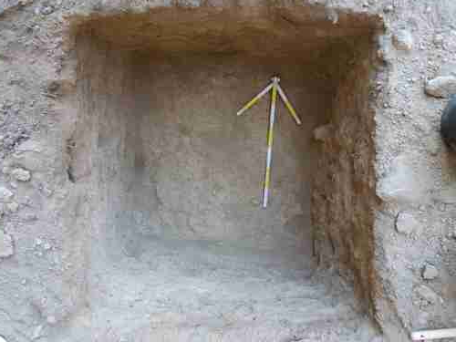
Fig. 2 – a view of square J (the depth of 40 cm corresponds to the bottom of XU 4)

Other anthropogenic features include places of burning activities situated mainly in the upper XUs of some the squares. In squares F, G and H, a burned feature was confined to less than 20 cm under the surface, while in squares I and L the burned excrements consisted of a sizeable structure visible in the stratigraphic section. Square E shows signs of stabling activities and contains few pottery fragments of possible Neolithic origin. Squares J and M were the deepest squares and yielded a small amount of evidence for human activities including several ceramic fragments and bones. One lithic artefact found in association is a retouched point which could potentially have a Paleolithic origin. This issue needs further investigation. Evidence for more recent human activities were also present on the cave floor.

Squares for excavating were continuously being selected throughout the excavation based on the likelihood of possible archaeological deposits and to include the greatest possible area in the time available. Of all the selected squares, only square K was not excavated, mainly due to a redirection of effort to other squares containing deeper deposits. The excavation did not reach bedrock in every square and many (potential) squares remain unexcavated so there is a lot of potential for further field research in this cave.

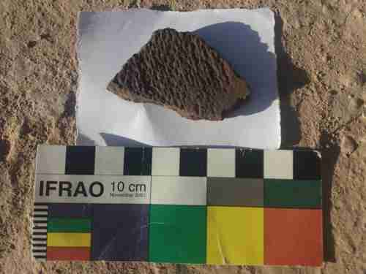
Fig. 3 – Fragment of a Neolithic ceramic with the surface structure clearly visible
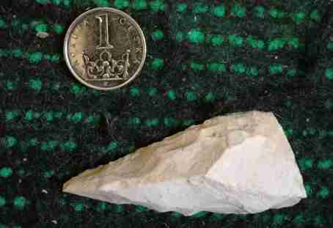
Fig. 4 – Stone artefact that could be of Palaeolithic origin
Geoarchaeological research
Kaptar Kamar Cave is a relict of an old cave system. It is 29.5 meters wide and 30.5 meters long. The roof is approximately 25.3 high in the entrance and 10.3 metres high in the rear of the cave. Its morphology is therefore the result of a long-term process. The surface of the cave slopes down from the rear to the entrance. A terrace consisting of limestone blocks was identified in the cave interior. These blocks fell down in the past, probably during, or at the end, of a cold climate period. The resulting morphology, i.e. the undulated surface of the interior, was lately smoothed by the sedimentation of colluvial deposits. These deposits are composed of unsorted silts with a large amount of limestone debris. The provenance of the silt fraction is mainly the loess material previously blown into the cave. The “in situ” non-redeposited loess sediments were identified, for example, in squares J and M located outside the dripline.

The uppermost parts of the cave were well protected from the wind so they may have been used in the Neolithic period for stabling and other human activities. In the field situation we observed relatively thick layers of stabling deposits as well as layers of fired material. The stabling deposits composed mainly of excrements mixed with silt and limestone debris were identified mainly in square E in the rear of the cave. The burned excrements mixed with the silt and limestone debris were identified mainly in squares I and L. The deepest sections excavated were located in the central part of the cave and at the western wall near the entrance. Sections in the central part display five distinct layers. The uppermost layer consists of mainly recent excrements overlying burned features. The underlying layer consists of unsorted silt with limestone detritus and frequent calcium carbonate dots. Underneath is a layer of unsorted silt with limestone debris and without calcium carbonate dots. The bottom of this layer is composed of a calcium carbonate sub-layer and it is likely to have formed in a more humid environment with intensive leaching. These suggestions are consistent with the zooarchaeological findings, i.e. by the unique presence of frogs and fish.

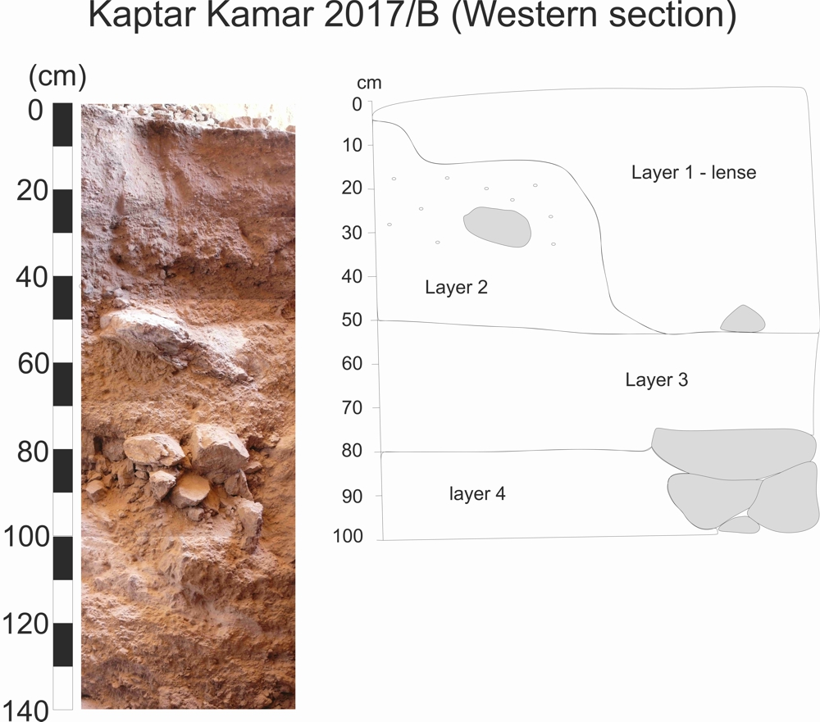
Fig. 5 - Example of sedimentary section documented in the centre of the Kaptar Kamar Cave. The layer 1 is represented by the lens of antropogenical sediments with the sharp transition into the layer 2 and 3 situated below. The layer 2 is composed of unsorted silt with the limestone detritus and a number of white calcium carbonate dots. The transition into the layer 3 is abrupt. The layer 3 is free of carbonates and composed of unsorted silt with the angular limestone detritus. The transition into the layer 4 (limestone debris or limestone rocks) is sharp. Thick layer of calcium carbonates developed on the transition between layers 3 and 4 as result of intensive leaching during some more humid period.

The deepest section was excavated at the entrance of the cave. The main type of deposit is again unsorted silt with limestone debris, which is sometimes impregnated with calcium carbonate hard crusts, at least down to 70 cm. At this depth a few lenses of typical loess deposit appear. At the depth of 100 cm an abrupt change into more lithified sediment was identified, i.e. unsorted silt with higher amount of limestone debris. The sedimentary bottom of the section was not reached, but at the depth of 220 cm a number of large stones started to appear.

Zooarchaeological research
The collection of zooarchaeological findings contains bones of domestic animals, microfauna as well as mollusca. The most common type of animal bone is sheep/goat (Ovis/Capra). A small proportion of the animal bones belongs to cattle (Bos taurus), dog (Canis familiaris) and donkey (Equus asinus f. domestica). Most bones were recovered from the upper parts of squares A, B, C as well as from squares H, E, F J and M.

Apart from the domestic animal bones (large mammals), bones of small animals (microfauna) were also identified. Bird bones (Aves sp. indet.) were also recorded. These bones together with the sheep/goat bones were the most common. The bones of bats were identified in square E in the upper part of the rockshelter. The remainder of microfauna consists of, for example, different species of rodents (microtus, mus muscullus, rattus species, critetus species, mustelidae). These groups were identified in all squares. The specific fauna, represented by frogs and fish, pointing to a more humid climate was identified in layer 3 of squares A, B, C and H.

In addition, fossils of bivalve and brachiopods were identified at the bottom of squares A and B. These findings are suggested to be manuports, because the type of the limestone building the rockshelter doesn´t contain such type of fossils.
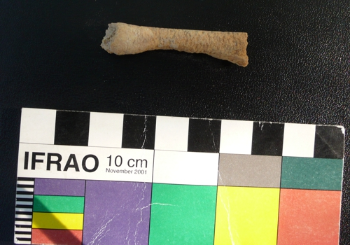
Fig. 6 – diaphysis of a sheep/goat femur with the signs of gnawing mark of rodents
Conclusions
Archaeological excavations in Kaptar Kamar Cave have confirmed the possible presence of Neolithic occupation, not previously demonstrated for this area. The cave was also occupied during Bronze Age and during Iron Age. Evidence of Palaeolithic occupation has not been demonstrated but the finding of a retouched point in square M and several chert flakes in other squares suggest it. These artefacts may have been redeposited from older layers. The lithological differences identified in study sections show that the sedimentological archive contains information about climate change during the Holocene period. The transition between Pleistocene and Holocene is probably represented by the fallen roof. The zooarchaeological findings confirm the suggested Holocene climatic changes already identified from the sedimentological record. Further interpretations will be completed after finishing the multiproxy analyses (radiometric dating, aDNA, geochemistry, archaeobotanical analyses, archaeozoological analyses).

The excavations confirmed that the environmental archive of the Kaptar Kamar Cave has a high potential for further research.

