On the measurement of elongational viscosity
using SER Universal Testing Platform

Petra Svrcinova, Alexander Kharlamov, Petr Filip
Institute of Hydrodynamics, Academy of Sciences of the Czech Republic, Prague

Abstract

The goal of this contribution is to present measurements of elongational viscosity for polyethylene material using SER Universal Testing Platform from Xpansion Instruments. The attention is paid to the possibilities how to check potential sagging of the samples measured and how to accelerate measurements for selected materials with the aim to eliminate possible material degradation.

Introduction

Viscosity represents one of the dominant characteristics of non-Newtonian fluids. Knowledge of a mere shear viscosity is for a number of polymer processes insufficient, and for a proper analysis of the whole process (as e.g. fibre spinning or injection moulding) a determination of elongational viscosity is inevitable. The means how to measure an elongational viscosity are not as common as in the case of shear viscosity where a number of standard or more sophisticated devices are commercially available. Determination of shear viscosity is - for standard materials - well elaborated and documented. This is not the case of elongational viscosity the determination of which is not so easy or trivial, and in fact no commercial device has been possible to choice. Research in elongational viscosity has been more or less concentrated to a limited number of scientific centres equipped with the individual devices representing prototypes proposed by the leading researchers in this branch. This situation has changed with an invention of so-called SER Universal Testing Platform from Xpansion Instruments that is now commercially produced by the well-known companies dealing in rheometry. This provides relatively simple possibility how to measure elongational viscosity. This contribution aims at a description and application of this device using polyethylene material, and discusses advantages and disadvantages of this approach.
Experimental

Highly branched LDPE (low-density polyethylene) material widely used in the film blowing process - LDPE Escorene, Exxon, USA (basic characteristics are summarised in Tab.1) - was chosen for the experiments carried out at the temperature of 180ºC.

Table 1 The basic characteristics of the used material.
Material | MFI [g/10min.] | Density  [g/cm³] | M_{w} [g/mol] | M_{n} [g/mol]
LDPE Escorene (Exxon, USA) | 0.33 | 0.922 | 366,300 | 30,280

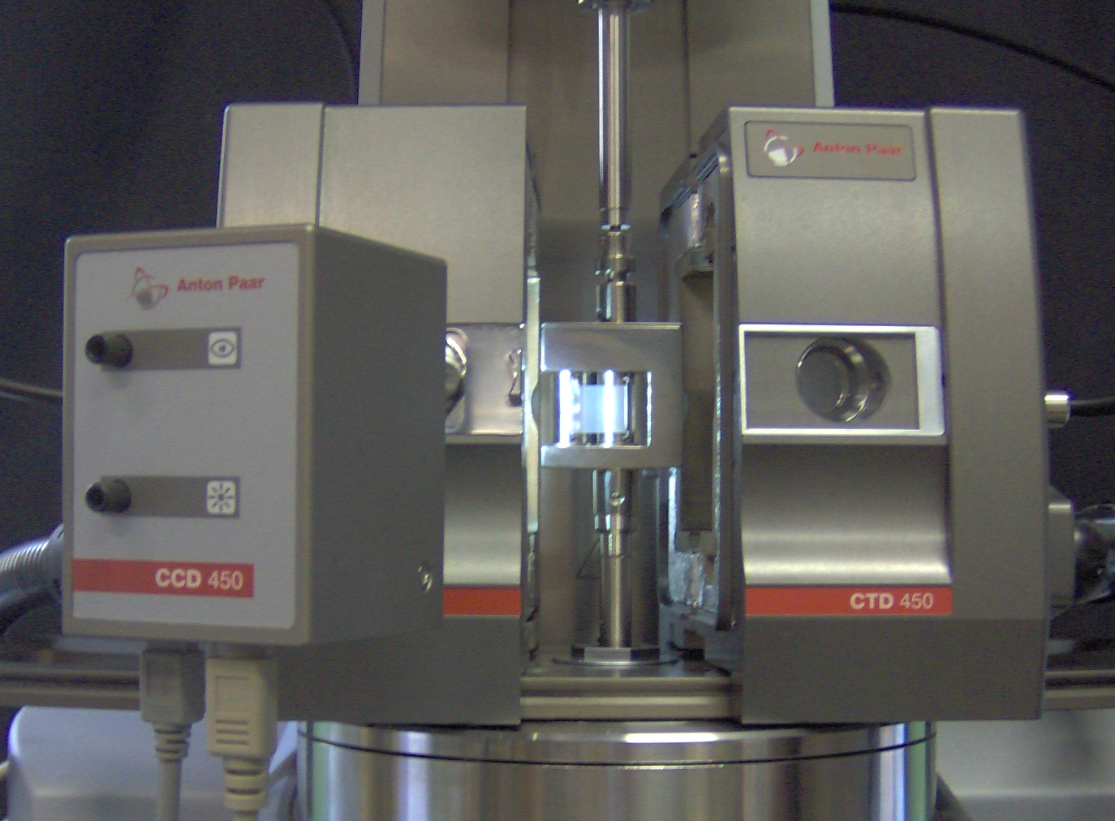

Fig.1 Experimental set-up (SER Universal Testing Platform surrounded by both halves of Convection Temperature Control Device CTD450) with a sample at room temperature

Uniaxial extensional viscosity was measured using the Physica MCR501 rheometer equipped with the newly designed Convection Temperature Control Device CTD450 and the SER Universal Testing Platform from Xpansion Instruments [1-3], see Fig.1.
The advantages of this experimental set-up used are as follows:
- with respect to a symmetrical design of the oven CTD450 (including an air inlet and outlet) a temperature distribution is sufficiently even in spite of asymmetrical geometry of the SER unit by use of which measurements of extensional viscosity are carried out (a complex formed by two counter-rotating wind-up drums with a supporting frame - see Fig.1);
- the oven CTD450 is equipped with so-called Digital Eye - a camera enabling to observe behaviour of material tested through the whole process of measurement. It is possible to record the experiment at full time span, to find an appearance of the material tested at any measured point, to document this behaviour in the graphs. Usage of this Digital Eye especially provides a check on possible unfavourable sagging of the samples (i.e. rectangular slabs fixed in-between the clamps) and gives a possibility of visual observation of material degradation (colour changes);
- apart from a camera system there is a possibility of effective visual monitoring directly through a glass aperture (an inner part of the oven is illuminated from inside);
- for some materials (including that in Table 1) it is possible to accelerate the measurements - and thus to reduce a possibility of material degradation - by removing the clamps serving for adjustment of the material samples to both drums, mere sticking to the drum walls is sufficient.

Fig.2 Behaviour of transient uniaxial extensional viscosity (material: Escorene).

The courses of transient uniaxial extensional viscosity measured for various rates of extension are depicted in Fig.2. Possibility to accelerate the measurements not applying the clamps for this material (as discussed above) is documented in Fig.3.

Fig.3 Comparison of transient uniaxial extensional viscosity (material: Escorene) measured with and without the clamps.

Conclusions

The experimental set-up discussed above provides more responsibility for proper evaluation of extensional measurement as a measuring process can be checked visually including a movie record allocating corresponding still pictures to the individual measured points.

Acknowledgement
This work has been supported by Grant Agency of the Czech Republic, Grant No. 103/08/1307.

References

[1] M.L.Sentmanat: Dual wind-up extensional rheometer. US Patent No 6,578,413 (2003).
[2] M.L.Sentmanat: Miniature universal testing platform: from extensional melt rheology to solid-state deformation behaviour. Rheol. Acta 43 (2004), 657-669.
[3] M.L.Sentmanat and S.G.Hatzikiriakos: Mechanism of gross melt fracture elimination in the extrusion of polyethylenes in the presence of boron nitride. Rheol. Acta 43 (2004), 624-633.

