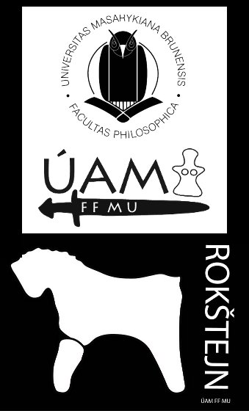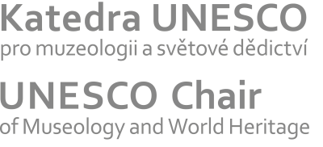

^{8th} Medieval and Post-medieval Pottery Workshop
Panská Lhota 16 – 19 August 2016.

First name and Surname
Organization name
Contact
Paper | Paper/ poster/ without paper or poster
Paper Title
Abstract | Paper (max. 30 minutes), possibility of presentation and discussion archaeological pottery finds or realization of experiment

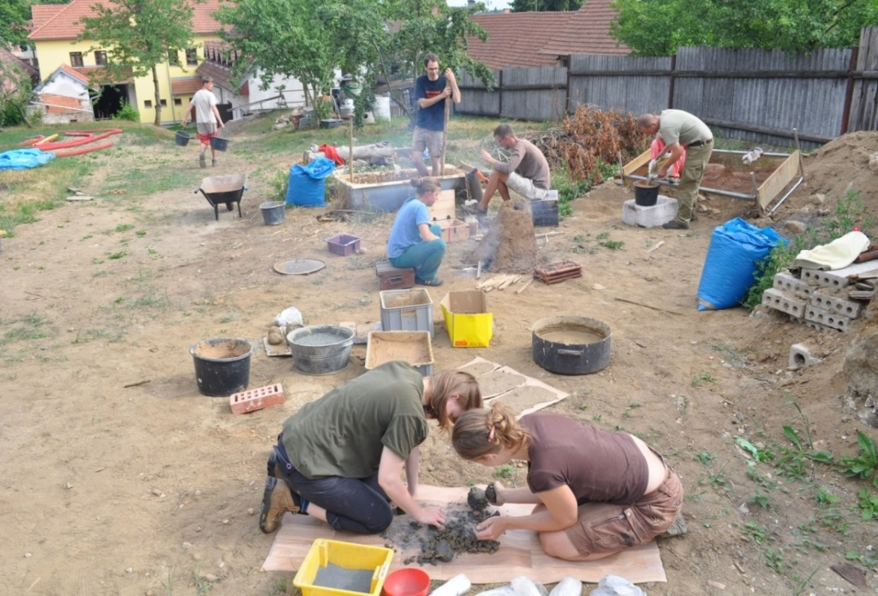

16.8. dinner | Yes/no
17.8. | Yes/no
18.8. | Yes/no
19.8. breakfast | Yes/no
Notice | Special requirements
Free accommodation in building of Department Archaeology and Museology (Masaryk univerzity) in Panská Lhota (Jihlava/ Iglau district). We will ensure transport from Jihlava/Iglau. Please submit your registration form until 31st July 2016 at: katkadolezalova@seznam.cz.

