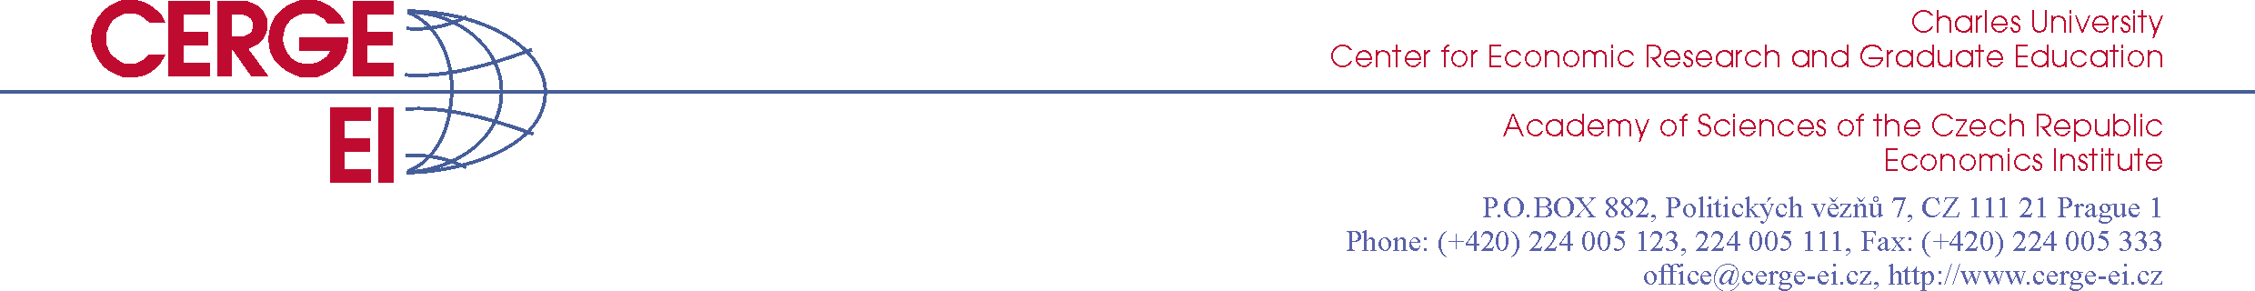

CALL FOR PAPERS
New Economic Talent 2015

The Center for Economic Research and Graduate Education – Economics Institute (CERGE-EI) and the Nadace CERGE-EI foundation invite university students and recent graduates to submit papers to the New Economic Talent competition. The competition is open to Bachelor's and Master's students (full-time or part-time) in any field and recent graduates (up to two years after graduation), who are interested in contemporary economic issues and wish to understand better the forces and processes that ‘shape the world’.
The competition is international, has two rounds, and its working language is English. Applicants submit a complete paper and an extended abstract to the first round. Selected finalists present their papers at CERGE-EI, Prague, in the second round. The topic of the paper can be in any sub-field of Economics, broadly defined. Papers will be judged based on originality, substance, analytical nature, and clarity of writing.
Prize for the winner consists of $1,000 USD and access to an international network of top economists (through attendance at events such as the Global Development Network conference, the Distinguished Speaker Series or the Graduation Gala.
Deadline for submissions is February 28, 2015.
Papers and extended abstracts should be sent to talent@cerge-ei.cz.
Further details (including detailed conditions) can be found at www.cerge-ei.cz/talent.

