|  |  |
| --- | --- |
|  |  |

A Press Release Prague, 13 November 2020

The Czech Academy of Sciences  
Národní 1009/3, 110 00 Prague 1   
www.avcr.cz

**The Stars at the Centre of the Milky Way - or “Enigmatic Rejuvenation”**

# 

**The “red giants” are an interesting type of huge and bright stars for astronomers. They are considered old even from the cosmic perspective as they have been evolving over a long period of time. Surprisingly, there is only a few of them in the region near the centre of our Galaxy, where an increased presence of younger stars has been revealed instead. A study, proposing a process to explain this anomaly, co-authored by the researchers from the Czech Academy of Sciences, has been published by *The Astrophysical Journal*.**

“We proposed an interesting mechanism to elegantly explain that any calculation imbalances are the result of a single process. We supported this hypothesis with calculations and a theoretical model,” Professor Vladimír Karas, the Director of the Astronomical Institute, explains. The study was conducted by him together with the researchers from the Institute of Physics of the Czech Academy of Sciences, the Center for Theoretical Physics of the Polish Academy of Sciences in Warsaw, and the Institute of Physics at the University of Cologne, Germany.

The Galactic Centre provides a unique laboratory for studying dynamic processes and interactions between nuclear star cluster and a supermassive black hole. A supermassive black hole with mass of 4.1 million of times the mass of the Sun is situated 8.1 parsec from the Earth towards the Constellation Sagittarius. The nuclear star cluster, which is a group of stars at the Galactic Centre, contains a vast range of stellar types, from late-type stars to hot stars. This implies that the star formation must have been taking place even under such complex conditions, albeit rather occasionally, with the highest intensity occurring about 10 billion years ago.

**A hundred of red giants missing**

On one hand, we can find a surprising number of young massive stars within the distance of up to one parsec. On the other hand, there is an obvious lack of bright red giants in comparison to a normal star population in other star clusters. Studies have shown that about a hundred of red giants is missing as compared to the usual statistics. Apparently, there is a mechanism that works in the vicinity of the Galactic Centre, which causes the red giants to die extensively and the hot blue stars to occur in increased numbers.

The authors of the study considered the indications that the Galactic Centre activity has not always been as low as it is now. Fermi bubbles, which are extensive columns of gamma radiation emitted above and below the galactic plane, prove that the activity of the Galactic core was much more intense several million years ago and, presumably, generated giant polar jets formed by a very hot and dense substance, and released at a high speed.

**Unable to withstand blasts from supermassive black hole**

“If a star was passing through a polar jet, it would necessarily have to lose a part of its outer envelope as a result of a surge pressure exerted on it by the jet. It seems only logical that it is particularly a star at its late development phase, primarily a red giant, that would suffer a mass loss. Consequently, astronomers may get confused by the outcome of the rejuvenating treatment as they are trying to determine the age of the star: the star may seem younger than it actually is.” **Michal Zajaček** says.

The star, unable to withstand the blast given by a supermassive black hole, loses its cold, unfolded, thin envelopes. This process works exactly like a skin-peeling treatment: the star, having lost its envelope, becomes seemingly rejuvenated. For instance, a star of the red giant type, whose unfolded radius before its entry into the polar jet was 120 times the radius of the Sun, might lose its atmosphere up to the distance of 30 Solar radii from the it’s centre, thus decreasing its dimensions four times.

“At the same time, its surface temperature would rise twice, thus decreasing its infra-red brightness eight times. The closer the star orbits the Galactic Centre, the more effective the process. In infrared observations, the cold giants will begin to disappear,” **Anabella Araudo** adds.

The authors have also estimated how likely it is that this event will occur. They have arrived at a surprising conclusion that a star passing through a polar jet during the jet's active phase cannot be ruled out. And more than that, if a star enters the polar jet due to the geometry of its orbit, the process will repeat itself more than a thousand times.

Such a star may then, indeed, suffer a significant mass loss. The proposed calculation enables the reconstruction of the surface brightness of stars in a nuclear star cluster and the estimation of the progress of the mass spectra. These data also agree with previous observations.

“The high quality of the model is referred to by several other predictions of what we should observe with future instruments if this model plays a significant role in the process of changing the statistics of the stars located near the Sagittarius A\* radio source,” Michal Zajaček concludes.

Red giants at a supermassive black hole have not died out. On the contrary, they have undergone a rejuvenating treatment, which turned them into the representatives of a seemingly younger hot blue star generation.

**Contact persons:**

**Prof. Vladimír Karas**, Astronomical Institute of the Czech Academy of Sciences

e-mail: vladimir.karas@asu.cas.cz

**Anabella Araudo, PhD.,** Institute of Physics of the Czech Academy of Sciences, ELI-Beamlines

e-mail: [anabella.araudo@eli-beams.eu](mailto:anabella.araudo@eli-beams.eu)

tel: 735 244 744

**RNDr. Michal Zajaček, PhD**., Polish Academy of Sciences

e-mail: [zajacek@cft.edu.pl](mailto:zajacek@cft.edu.pl)

tel: 00421 905 692 726

**Link to study:**

**[doi.org/10.3847/1538-4357/abbd94](https://doi.org/10.3847/1538-4357/abbd94" \t "_blank)**,

The Astrophysical Journal, M. Zajaček, A. Araudo, V. Karas, B. Czerny, & A. Eckart (2020), „Depletion of bright red giants in the Galactic center during its active phases“

**About authors:**

**Dr. Michal Zajaček** graduated from astronomy and astrophysics at the Astronomical Institute of Charles University in Prague, later worked at the University of Cologne, Germany, and currently is a member of the ***Center for Theoretical Physics of the Polish Academy of Sciences*** in Warsaw.

**Dr. Anabella Araudo** came to the Czech Republic from the University of Oxford; currently she works at the Institute of Physics at the ***ELI Beamlines*** laser centre in Dolní Břežany near Prague. She studies high energy processes in cosmic and laboratory plasmas.

**Prof. Vladimír Karas** leads a group of relativistic astrophysics at the ***Astronomical Institute of the Czech Academy of Sciences*** in Prague, of which he is the Director. He explores processes near black boles and compact stars with a very strong gravitation.

This study was co-authored by Professor Bozena Czerny from the Polish Academy of Sciences and Professor Andreas Eckart form the Institute of Physics of the University in Cologne, Germany.

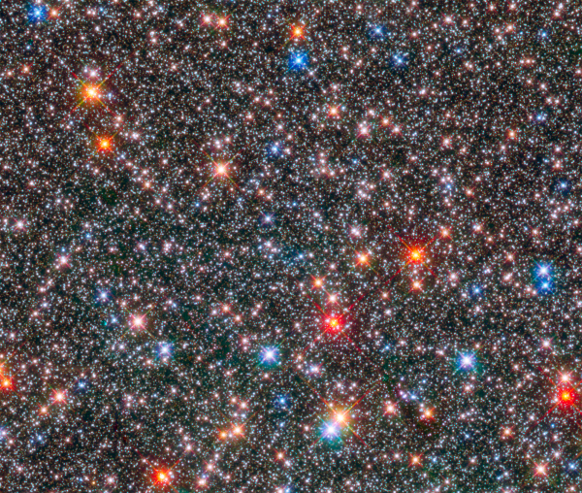

Stars in the centre of the Milky Way on an image taken by the Hubble Space Telescope. A region located 26 000 light years (8.1 kpc) captured by a wide-angle camera in an exposition sequence close to an infrared and visible light spectrum. Different colours of the stars correspond to different temperatures on a star’s surface. A more details spectrum provides information about the chemical composition and the evolution of the stars. The shown 1.8 x 1.8 arcminute field corresponds to a distance of about 13 light years across the image (image: NASA/ESA/STScI).

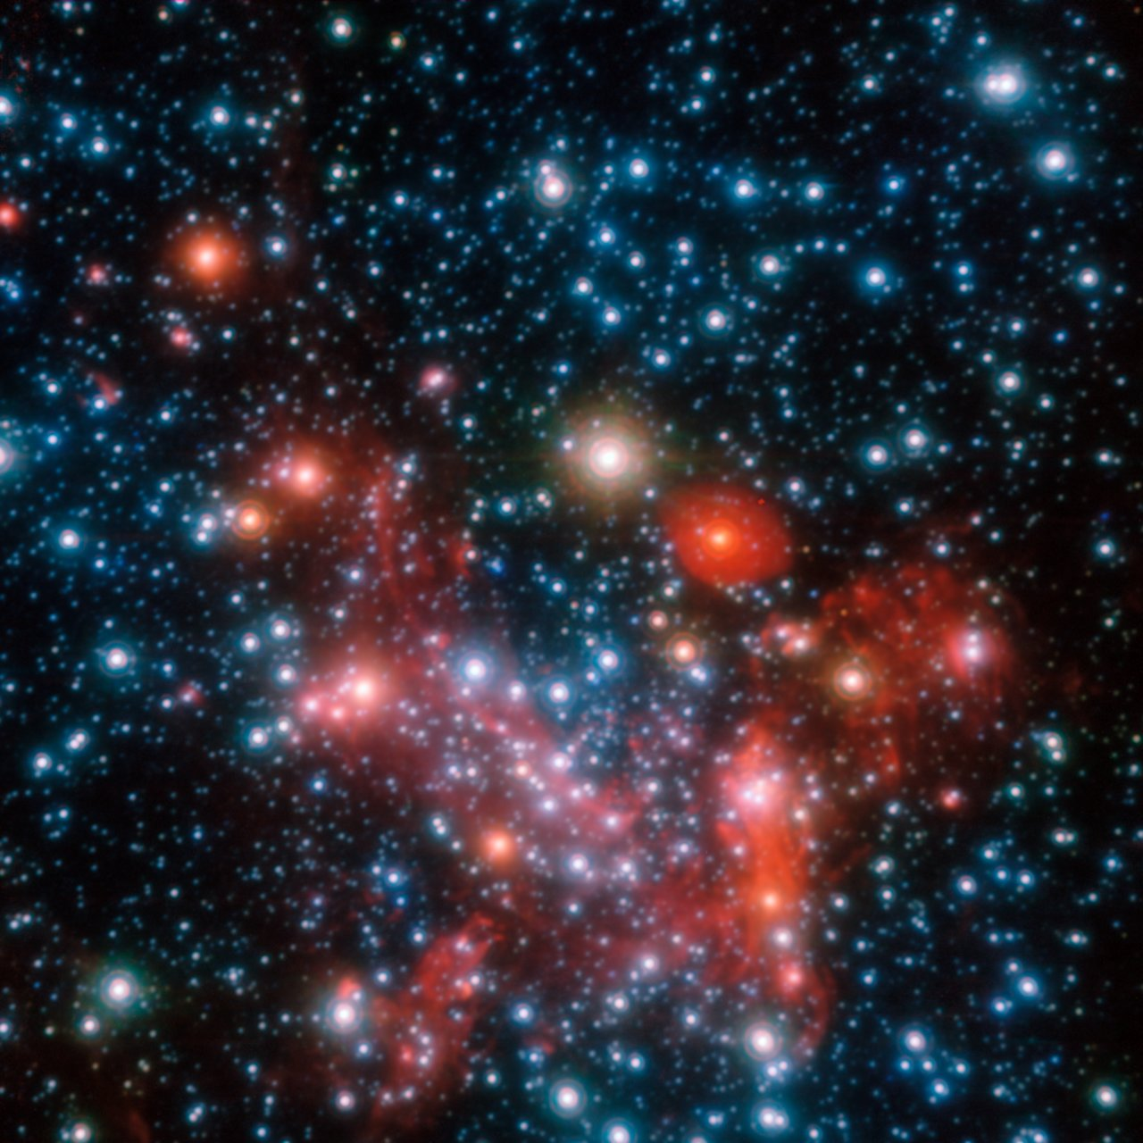

The view of the inside of the Milky Way requires the use of the radiation of a wave-length other than the wave-length of the visible light, which cannot penetrate the region due to large amounts of interstellar dust. A photograph taken in the infrared range by the VLT telescope (Very Large Telescope) of the European Southern Observatory enabled the penetration of the dusty environment in order to display almost the very centre of the Galaxy, which hides the black hole. The image captures only a 0.4 x 0.4 of arcsecond field (image: ESO).

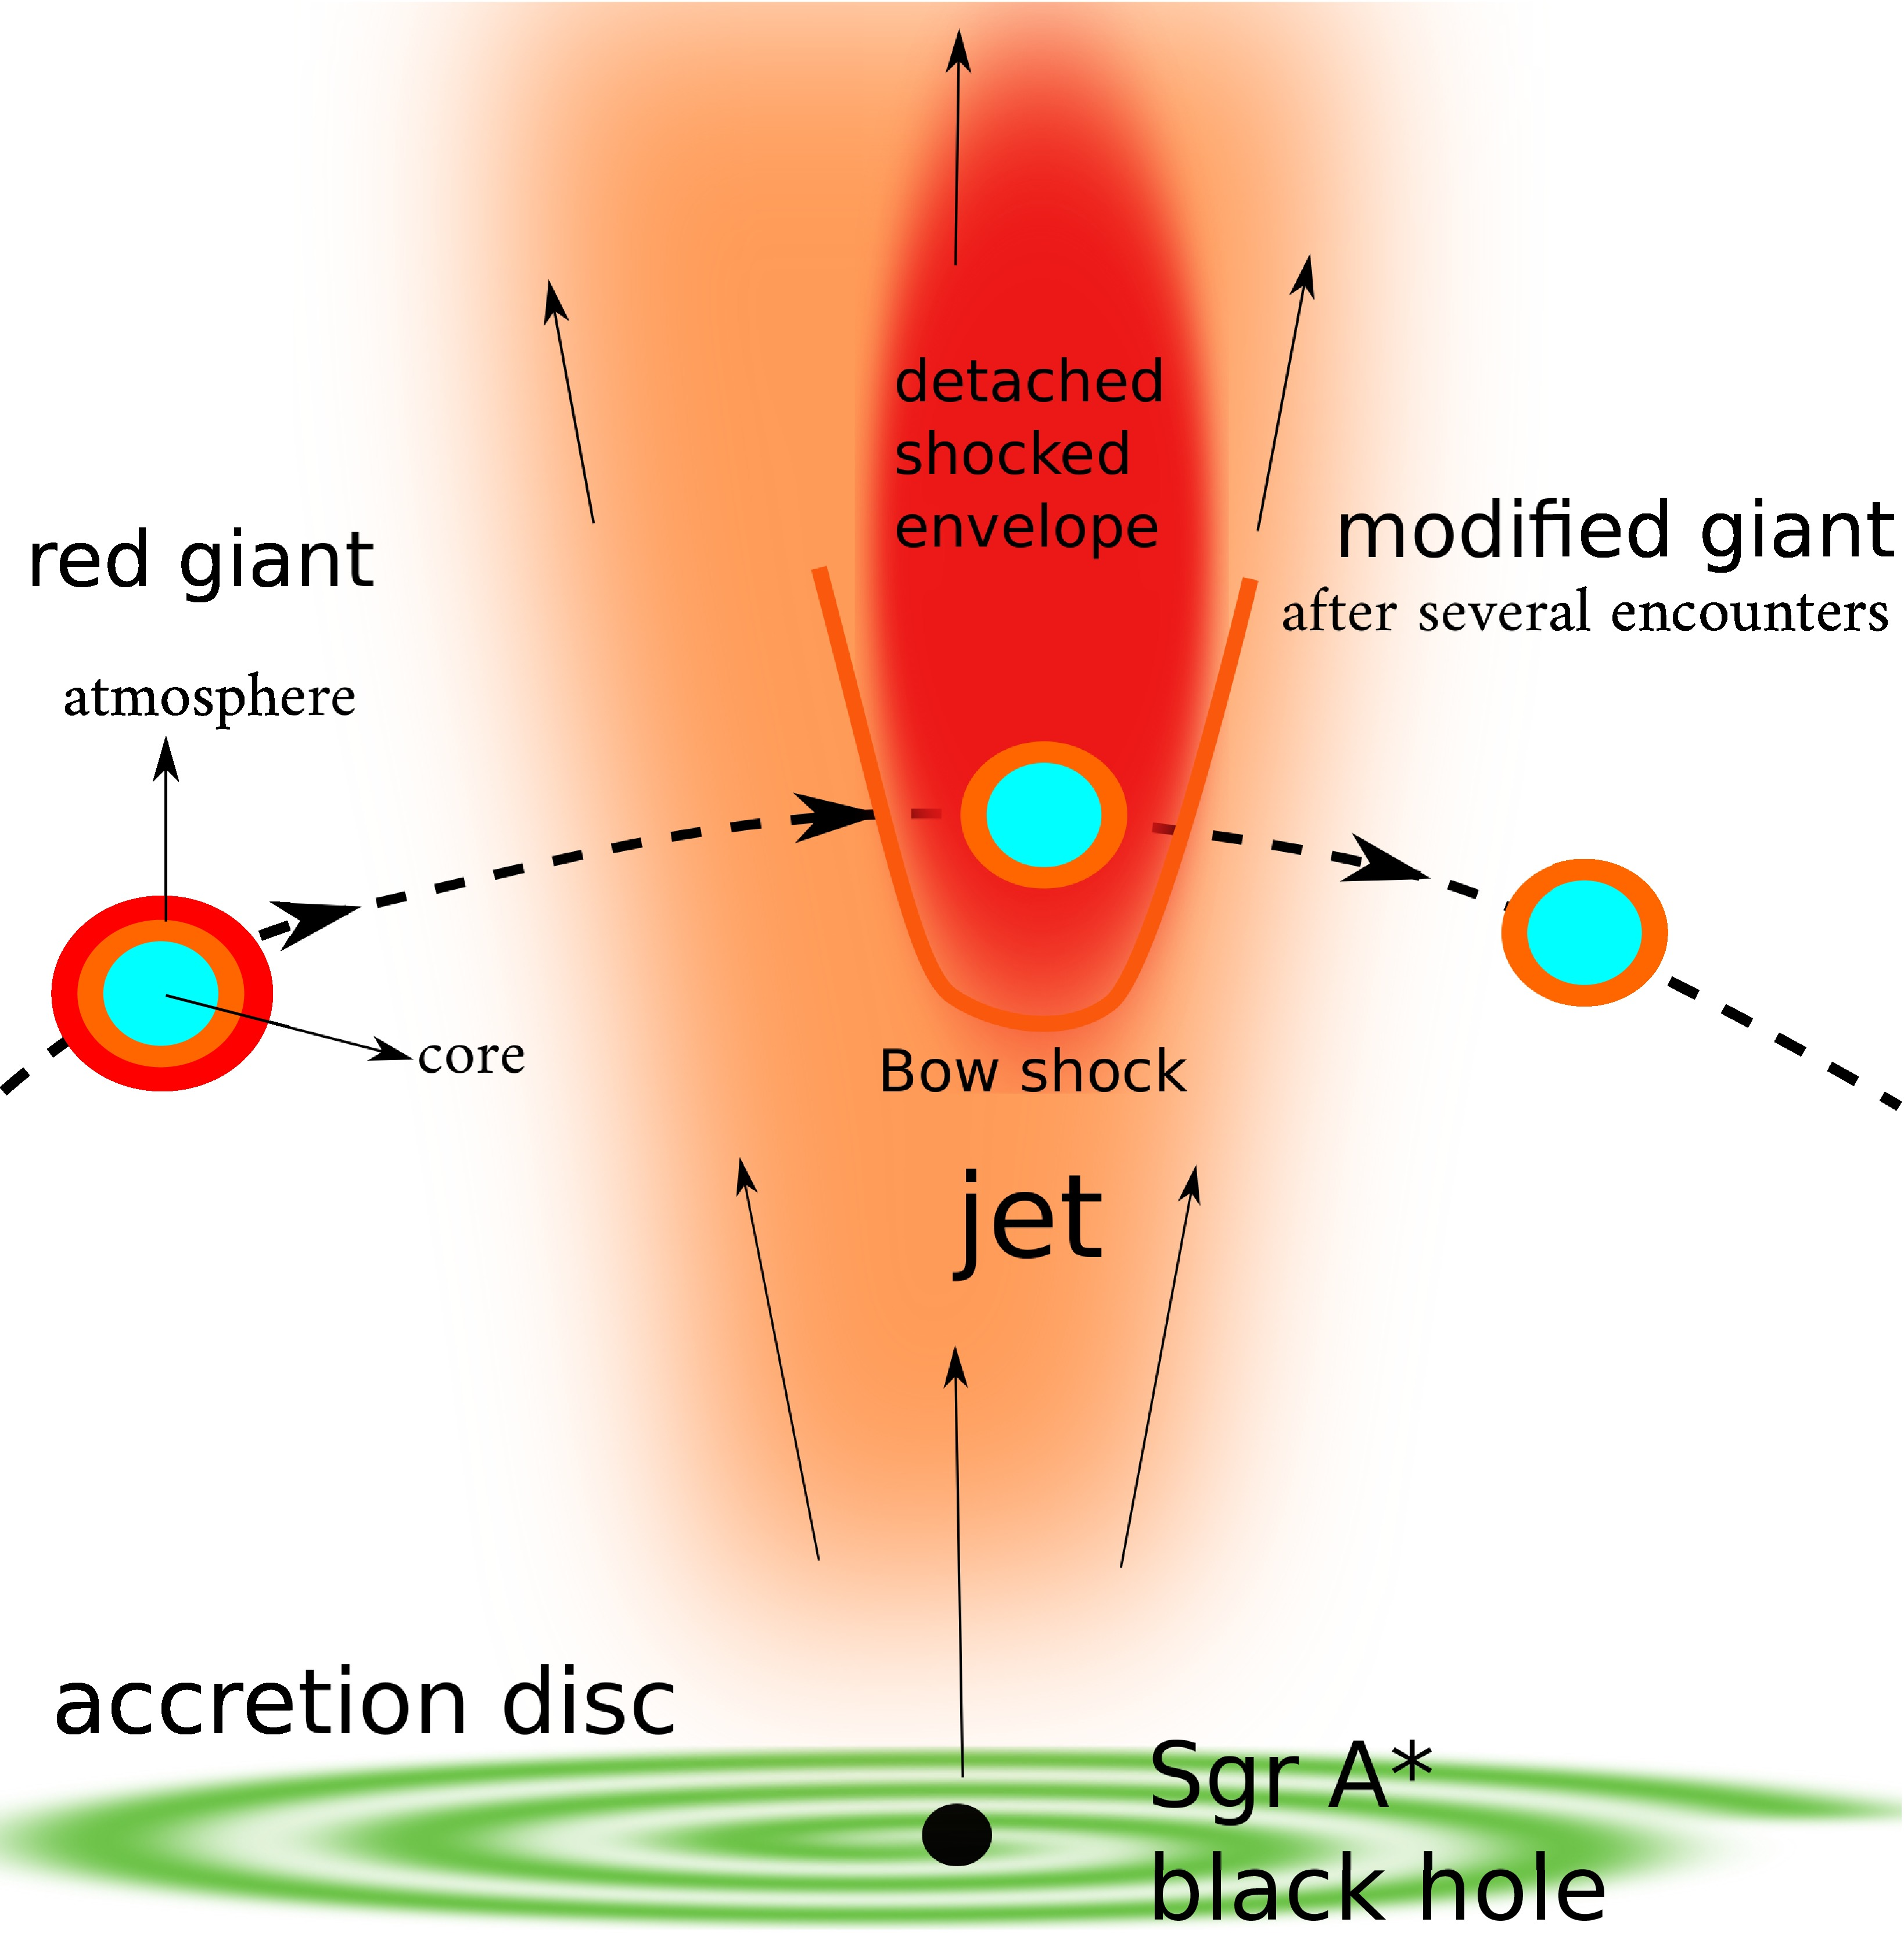A schematic illustration showing a red giant – a very large, massive star with an extensive atmosphere - passing through a jet flowing from Sgr A\* black hole. The gas creates shock waves, the star loses its atmosphere, increases its surface temperature and changes its spectral classification. As a result, the star may appear younger (figure was taken from the article by Zajaček et al. 2020).